

Matomo Implementation & Reporting SOP Document

Xerago – Digital Analytics


Table of Contents

What is Matomo …..……..………..………….…………………………………………………………….. 4

Objective of Matomo…..……….…….….………………………………………………………………... 4
Key Features of Matomo…..………………………………………………………………….............. 4
Account Setup - Matomo Cloud account …....…..….…………………………………………… 5
Base Code Configuration - Website Implementation Guide .……………………………..9
Matomo Tag Manager …………..…………………………………………………………………………12
Data Layer…….. ...………………………..…………………………………….……………………………..14

Page View Tracking ……………………………………………………………………………..…………..16

Event tracking - Data layer Events and Variables ………………………………………………18

Custom Dimensions and Custom Variables ………………………………………………………22

Goal and Conversion Tracking ………………………………………………………………………….25

Cross Domain Tracking …………………………………………………………………………………….28

Funnel Analysis ………………………………………………………………………………………………..30

Segmentation …………………………………………………………………………………………………..34

Real-time reports ……………………………………………………………………………………………..38

Campaign Tracking ……………………………………………………………………………………………39

Reports and Dashboards …………………………………………………………………………………..41

Attribution Tracking ………………………………………………………………………………………….43

Table of Contents
Data Sampling ….................................................................................................45

Data Privacy and Compliance …………………………………………………………………………45

Custom Alerts …..................................................................................................49

Heatmaps and Session Recording …………………………………………………………………..52

Offline Data Integration and Report ……………………………………………………………….56

Data Dictionary and Combine data from different source ……………………………...58

Data Export …………………………………………………………………………………………………….59

Data Visualization …………………………………………………………………………………………..60

What is Matomo
Matomo (formerly Piwik) is an open-source web analytics platform that provides insights into website and app performance by tracking user behavior. It serves as an alternative to tools like Google Analytics, offering greater control over data privacy and ownership.
Matomo offers two ways to set up and manage your analytics:
1. Matomo Cloud (Managed Hosting):
- Matomo hosts the analytics platform on its servers.
- Ideal for users who want an easy setup without server management.
- Requires creating an account at Matomo Cloud.
2. Matomo On-Premise (Self-Hosting):
- You host Matomo on your own servers.
- Offers full control over the data and infrastructure.
- Involves downloading and installing the Matomo software from Matomo On-Premise.
Each of these hosting options requires separate installation or subscription, but they serve the same purpose with different levels of control and management.
Objective of Matomo
To utilize Matomo Analytics for tracking and analyzing user interactions across websites and applications, enabling data-driven decision-making, optimizing performance, and enhancing user experience, all while maintaining strict adherence to privacy regulations and data security.
Key Features of Matomo
- Website & App Tracking: Tracks visits, page views, and user interactions across web and mobile platforms.
- Data Ownership: Users fully own their data, as Matomo can be hosted on their servers (on-premise option).
- Privacy-Focused: Complies with GDPR and other privacy regulations with features like IP anonymization and cookie consent tools.
- Customizable Analytics: Provides customizable dashboards, reports, and integrations to suit various business needs.
- Advanced Features: Heatmaps, session recordings, A/B testing, e-commerce tracking, and goal tracking.
- Tag Management: Includes Matomo Tag Manager for efficient deployment of tracking scripts.
- Flexible Hosting: Available as a self-hosted or cloud-hosted solution.

Account Setup - Matomo Cloud account
It is important to plan ahead before creating a Cloud account to start off on the right foot and get the most out of Matomo. There are two important decisions to be made to correctly set up a Matomo account:
- How to choose the right account name
- How to create a Matomo site
Choosing a name for your Cloud account
The first step is to create a Matomo trial account with an appropriate name, as it cannot be changed later. For companies with a single website (e.g., www.mycompany.com), this step is simple just enter the site name as shown in the example below:

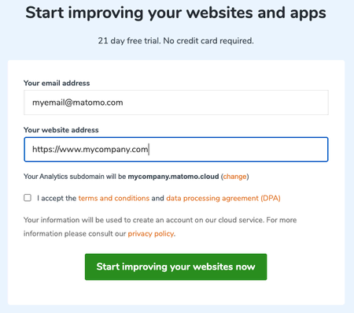

The account name will be MYCOMPANY.MATOMO.CLOUD, derived from the website name www.MYCOMPANY.com. For agencies or businesses managing multiple websites (e.g., www.mycompany1.com, www.mycompany2.com, etc.), it's important to choose a meaningful account name. Keep in mind that the account name doesn't have to match a website name simply enter www.MYNAMEHERE.com to create the account MYNAMEHERE.MATOMO.CLOUD.

If you need to change the account name displayed, simply click on the "change" link and you will be able to edit the account name.
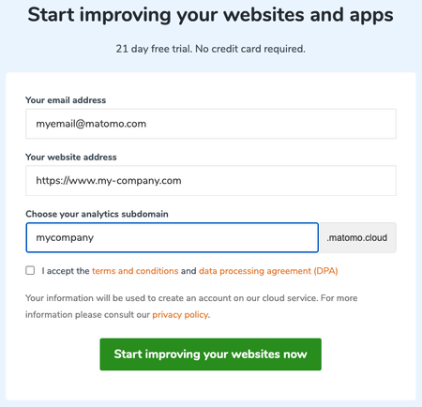

Creating a Matomo site
Matomo automatically creates the site based on the website URL provided (e.g., www.mycompany.com as shown above), and the site name will appear in the "All Websites Dashboard" as displayed below:
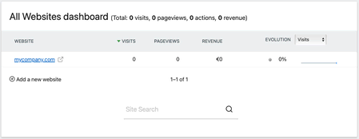
A Matomo site is typically created for each individual website. If you manage multiple websites, you'll need to add them separately. Here's how you can create and manage websites in Matomo.

Create and manage websites
Matomo can track an unlimited number of websites, including pages across multiple domains and subdomains. While most users track between 1 to 10 websites, some Matomo servers are capable of tracking over 10,000 websites
Add a Website
To add a new website in Matomo, you must be logged in as the super user. First, click on Administration to access the administration area. Then, under Websites/Measurable, click on Manage. This page allows you to create, update, and delete websites.
To create a new site, click on Add a new website. The website form will display all the options you can specify:
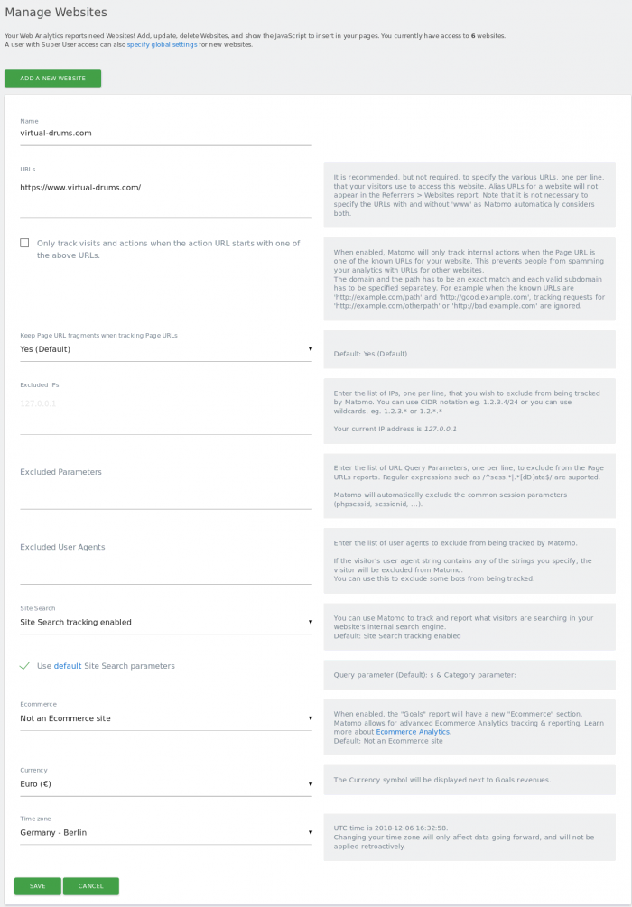
Here are the attributes you can specify for each website in Matomo:
- Name: The name of the website.
- Alias URLs: Domains and subdomains that are tracked under this website. This ensures that tracked domains don't appear in the Referrer report.
- Excluded IPs: A list of IPs or IP ranges (e.g., 132.4.3.* or 143.2..) that will be excluded from tracking across all websites.
- Excluded Parameters: URL query parameters (e.g., session parameters) that should be excluded to keep the Behaviour > Pages reports clean and easy to analyse.
- Time Zone: Specifies the time zone for the website’s data reports. If updated, the change will only affect future reports.
- Currency: The currency symbol that will be displayed next to revenue in your goal reports.
- Ecommerce: Enables ecommerce tracking and reports if your website is an online store.
Additionally, you can set Matomo-wide values for some of these attributes at the bottom of the page, such as:
- IP exclusions and URL parameters to exclude for all websites, ensuring consistent tracking across the platform.
Update and Delete Websites
To update a website in Matomo, follow these steps:
- Click on Administration (cog icon) > Websites/Measurable > Manage.
- Select the website you wish to edit and click on Edit.
- Update one or more fields as needed, and then click Save.
To delete a website:
- Click on Administration (cog icon) > Websites/Measurable > Manage.
- Click on Delete next to the website you want to remove.
Caution: Deleting a website is irreversible and will also delete any associated Matomo Tag Manager containers. When you click the delete icon, you will be prompted to save a copy of the container configurations. To confirm the deletion, enter your superuser password.

Base Code Configuration - Website Implementation Guide
Step-by-Step Guides for Popular Website Builders and CMS,
Popular website platforms (CMS): WordPress, Joomla, Webflow, Shopify store, SquareSpace, Wix, GoDaddy Website Builder, Drupal, Jimdo.
Additional Integrations Available:
Matomo can also be integrated with various other systems and platforms, including:
Mobile Apps: Android and iOS apps
Tag Managers: Google Tag Manager (GTM)
Mobile Frameworks: Ionic mobile apps
E-commerce Software: Matomo can integrate with various ecommerce.
Manually Embedding the Tracking Code:
If your website platform is not listed above or doesn't have an existing integration, you can still integrate Matomo by manually adding the tracking code:
Get the Matomo Tracking Code:
- You can find the tracking code in your Matomo dashboard under Administration > Tracking Code.
Insert the Code Manually:
- Place the tracking code in the <head> section of your website's HTML.
Example: How do I install the Matomo tracking code on WordPress
Adding Matomo tracking to your WordPress site is straightforward. You can either use the simple WordPress plugin.
Prerequisites
- A Matomo account: Cloud or On-Premise (self-hosted).
- Administrator account in WordPress
- WordPress.com site with a Business, Commerce or Enterprise plan, or a Self-hosted WordPress site.
Steps to start tracking in Matomo
1. To install the Connect Matomo (WP-Matomo) plugin in your WordPress site, follow these steps:
- Log in to WordPress: Ensure you are logged in as an administrator.
- Navigate to Plugins: In the left menu, click on Plugins > Add New.
- Search for the Plugin: In the search field on the Add Plugins page, type Connect Matomo.
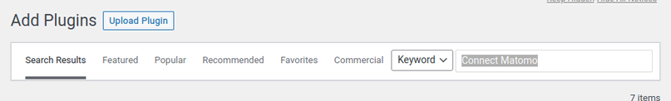

- Install the Plugin: Once you find the Connect Matomo (WP-Matomo) plugin, click Install Now.
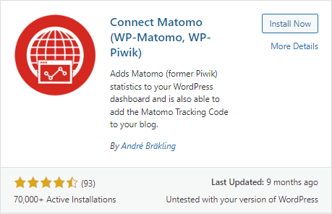
- Activate the Plugin: After installation, click Activate to enable the plugin on your site.
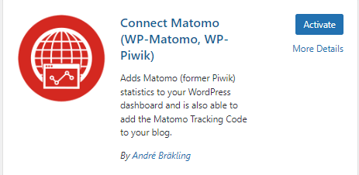

2. In the left menu, click Settings > WP-Matomo.
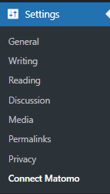
3. In the Matomo Mode dropdown, choose the Self-hosted (HTTP API, default) option.
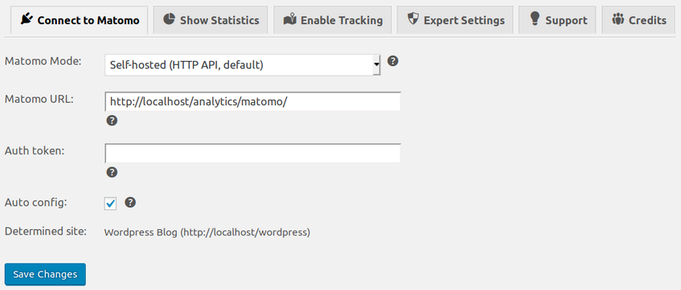
4. In the Matomo URL text field, enter your Matomo URL (e.g., https://analytics.example.com).
5. In the Auth token text field, enter your Matomo authentication token. (Refer to the instructions on how to find the Auth Token.)
6. Ensure the Auto config checkbox is selected, then click Save Changes.
7. You should see a message saying, "Connect Matomo is successfully connected to Matomo." If you don't see this message, double-check that the values you entered are correct and try again.
8. Next, click on the Enable Tracking tab.
9. In the Add tracking code dropdown, select Default tracking.
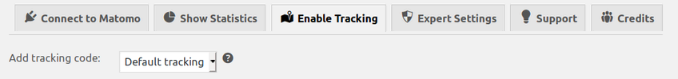
10. Click on Save Changes, and a success message will appear confirming the update.

Example snippet code:
<!-- Matomo -->
<script>
var _paq = window._paq = window._paq || [];
/* tracker methods like "setCustomDimension" should be called before "trackPageView" */
_paq.push(['trackPageView']);
_paq.push(['enableLinkTracking']);
(function() {
var u="https://xeragoanalytics.matomo.cloud/";
_paq.push(['setTrackerUrl', u+'matomo.php']);
_paq.push(['setSiteId', '1']);
var d=document, g=d.createElement('script'), s=d.getElementsByTagName('script')[0];
g.async=true; g.src='https://cdn.matomo.cloud/xeragoanalytics.matomo.cloud/matomo.js'; s.parentNode.insertBefore(g,s);
})();
</script>
<!-- End Matomo Code -->
Matomo's default tracking capabilities
When the JavaScript Tracking code is configured on a website, Matomo tracks the following by default:
Page views: Tracks page views when the JavaScript tracking code loads and executes on each page view
User IP address: Tracks the user's IP address
Date and time: Tracks the date and time of the request

Matomo Tag Manager
Matomo Tag Manager enables you to manage and consolidate all your tracking and marketing tags in one place. These tags, also referred to as snippets or pixels, are typically JavaScript or HTML code that allows you to integrate various functionalities into your site with ease.
The process involves the following key components:
- Tags: Snippets of code (usually JavaScript or HTML) that are added to your site.
- Triggers: Define the conditions under which a tag should be activated.
- Variables: Retrieve and store data that can be used by both tags and triggers.
- Versions and Publish: Versions allow you to save a snapshot of the current container configuration, enabling you to revert to a previous version if necessary. You can choose not to publish it immediately, giving other users a chance to review and provide feedback on your changes. This feature also helps recover from errors and makes it easy to track all previously deployed tags, triggers, and variables. Once you're satisfied with the configuration, you can proceed to publish it.
Simply put, Matomo Tag Manager enhances Matomo Analytics by adding powerful tag management capabilities. Just as a CMS simplifies content publishing for your website, a Tag Management System (TMS) allows you to seamlessly embed first- and third-party application resources into your website with ease.
Purpose:
The purpose of Matomo Tag Manager is to provide an efficient way to manage, deploy, and unify tracking and marketing tags across your website. It enables seamless integration of first- and third-party resources, such as analytics scripts, pixels, and custom code, without requiring manual code modifications. This simplifies website management, improves flexibility, and ensures consistency in tracking and data collection.

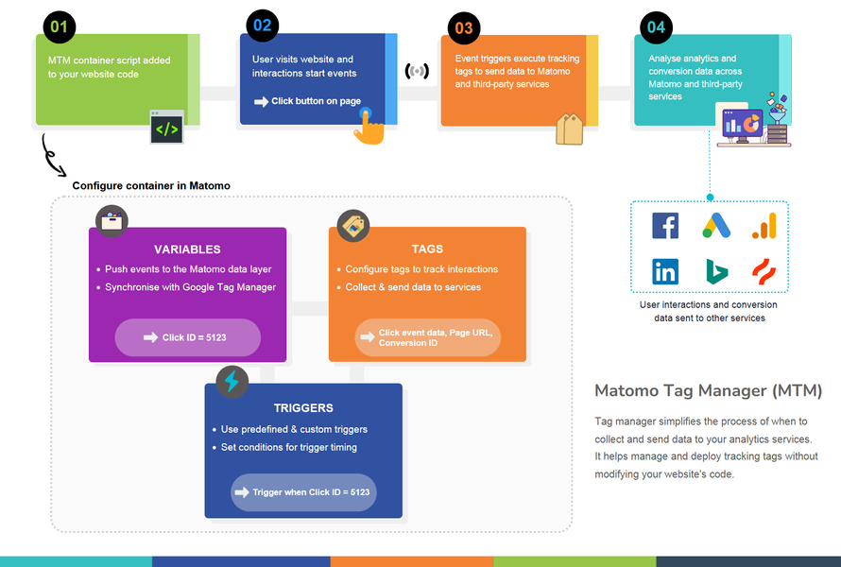

How to Use Matomo Tag Manager
1. Set up Matomo Tag Manager
- Create a Matomo account: If you haven't already, sign up for a Matomo Cloud or On-Premise account.
- Access Tag Manager: Log in to your Matomo account, and navigate to the Tag Manager section.
2. Create a Container
- Go to Container Management: Once in Tag Manager, click on Containers and create a new container.
- Choose Website or App: Select the type of container depending on whether you're tracking a website or a mobile app.
3. Add Tags
- Create Tags: In your container, click on Tags and then add New Tag. Tags can include analytics scripts (like Google Analytics or Matomo’s tracking script), marketing pixels (such as Facebook or LinkedIn), or other custom code.
- Choose Tag Type: You can choose from pre-configured tag templates (like Matomo Analytics or Google Analytics) or add a custom tag (e.g., JavaScript or HTML).
4. Set up Triggers
- Create Triggers: Define the conditions when a tag should be fired. Triggers can be set for actions such as page views, button clicks, or form submissions.
- Choose Trigger Type: You can select from a variety of trigger types such as Page View, Click, or Custom Event.
5. Add Variables
- Create Variables: Variables capture dynamic data that can be used in tags and triggers. For example, you can use variables to track specific URLs, page titles, or custom data.
- Configure Variable Type: Choose the type of variable you need, such as URL Variable, JavaScript Variable, or Data Layer Variable.
6. Test Your Configuration
- Preview Mode: Before publishing, use the Preview mode to test the configuration. This allows you to see how tags, triggers, and variables behave on your site.
- Debugging: Check the Tag Manager's preview/debug console to ensure tags are firing as expected.
7. Publish Changes
- Create Versions: Once you're satisfied with your configuration, save it as a version.
- Publish: When ready, click Publish to apply the changes to your live website or app.

Data Layer
When implementing Matomo Tag Manager's data layer, it works similarly to how Google Tag Manager (GTM) utilizes the data layer. The data layer is a JavaScript object used to store and manage data that can be passed to tags, triggers, and variables in Matomo Tag Manager.
Example: Ecommerce Tracking using the data layer
Step 1: Create a Data Layer variable, such as PurchaseInfo, with the "Data Layer Variable Name" set to ecommerce.purchase.
Step 2: Set up a Custom Event trigger that activates when the event name is purchase.
Step 3: Create a Custom HTML tag that fires based on this Custom Event trigger to track your Ecommerce interaction. For example, to track an Ecommerce order, you would write:
Snippet Code:
<script>
window._paq = window._paq || [];
var purchaseInfo = {{PurchaseInfo}};
//console.log(purchaseInfo);
window._paq.push(['trackEcommerceOrder',
purchaseInfo.id, // (required) Unique Order ID
purchaseInfo.revenue, // (required) Order Revenue grand total (includes tax, shipping, and subtracted discount)
purchaseInfo.orderSubTotal, // (optional) Order sub total (excludes shipping)
(purchaseInfo.tax || 0), // (optional) Tax amount
(purchaseInfo.shipping || 0), // (optional) Shipping amount
(purchaseInfo.discount || false) // (optional) Discount offered (set to false for unspecified parameter)
]);
</script>
Step 4: Lastly, in your Ecommerce backend website/app (outside of Matomo Tag Manager), trigger the tag manager event using the following
JavaScript code:
window._mtm = window._mtm || [];
window._mtm.push({
'event': 'purchase',
'ecommerce': {
'purchase': {
'id': 'dynamic value',
'revenue': 'dynamic value',
'orderSubTotal': 'dynamic value',
'tax': 'dynamic value',
'shipping': 'dynamic value',
'discount': 'dynamic value',
}
}
});
Replace the “dynamic values” with the actual values for the Ecommerce interaction in the JavaScript code. This will trigger the "purchase" event in Matomo Tag Manager, which activates the custom HTML tag and tracks the Ecommerce interaction in Matomo using the dynamic variables from your Data Layer.

Page View Tracking
By default, Matomo creates a Pageview trigger and a Matomo Analytics – Pageview tag to track your pageviews automatically. To check if the Pageview trigger and tag are already set up, navigate to the Triggers and Tags sections in Matomo Tag Manager.
If they don't exist, follow these steps to set up pageview tracking in Matomo Analytics using Matomo Tag Manager:
1. Create a Matomo Configuration Variable
- Navigate to Variables and click “Create new Variable”.
- Under “Choose a type of variable” click “Matomo Configuration“.
2. Create a Pageview trigger
- Navigate to Triggers and click “Create new Trigger”.
- Click “Pageview” under “Pageview” section.
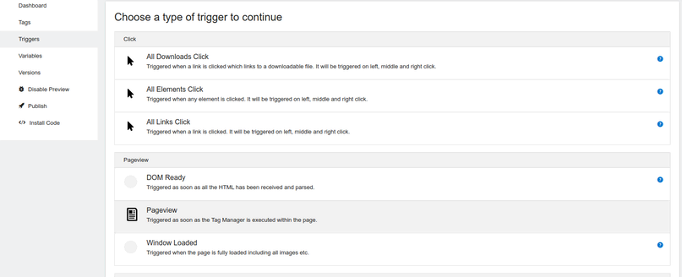
- Give your trigger a name, and click “Create New Trigger”
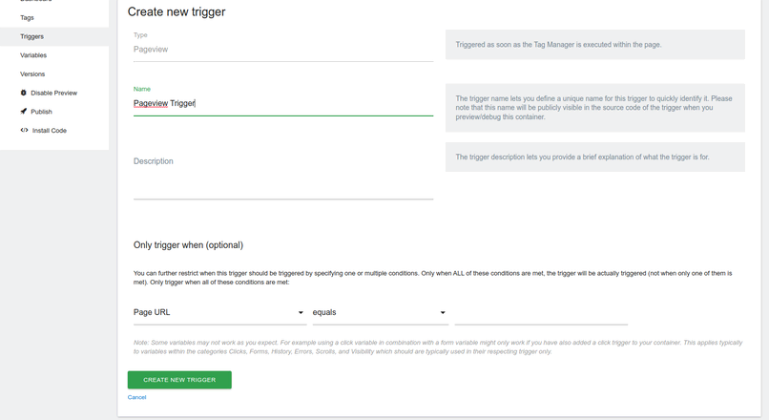
3. Create Matomo Analytics tag
- Navigate to Tags and click “Create new Tag“.
- Click “Matomo Analytics” under “Analytics” section.
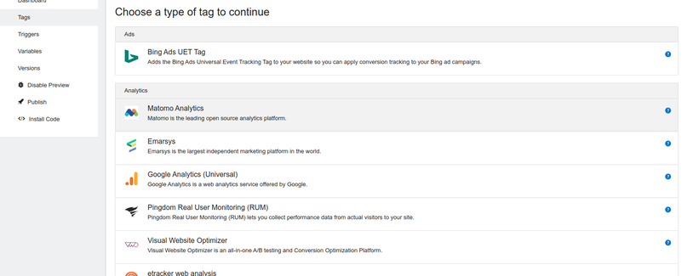
- In the section “Configure when the tag should do this”, under “Execute this tag when any of these triggers are triggered” select the “Pageview” trigger created in step 1.
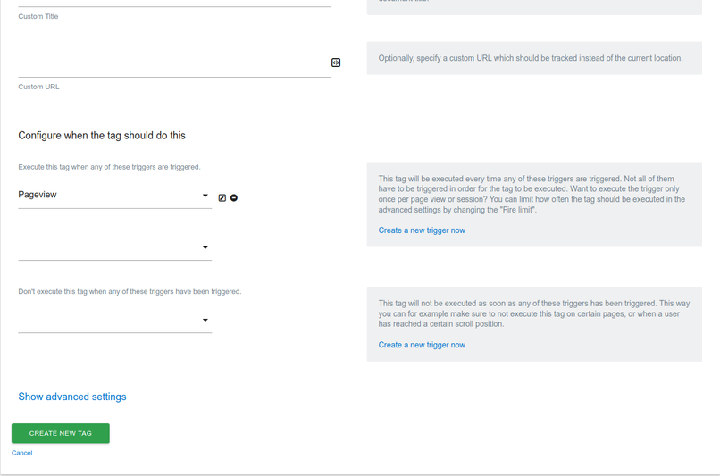
4. In the left menu, click on "Publish".
5. Enter a version name, such as 1.0.
6. Click the green "Create New Version and Publish Release" button.
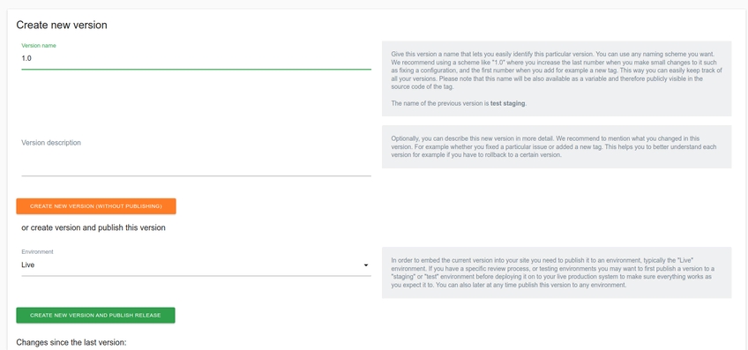
7. Install the Matomo Tag Manager code on your site.
8. When creating triggers with conditions based on Page URLs containing non-Latin characters, make sure to use the encoded URL format.

Event tracking - Data layer Events and Variables
Matomo Tag Manager (MTM) can track events by using events pushed to an existing Google Tag Manager (GTM) dataLayer.
By default, MTM automatically copies any values from the GTM data layer into the MTM data layer when the page loads. With the release of Matomo 5.2.0-b3, a new container setting has been introduced that allows events from the GTM dataLayer to be actively synchronized to the MTM dataLayer. Learn more about synchronizing events from the GTM dataLayer to the MTM dataLayer.
For example, if you have an existing event in GTM, like a successful form submission that is pushed to the GTM dataLayer, it will appear in the console as follows:
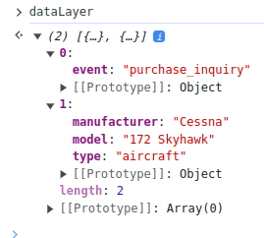
Along with the purchase_inquiry event pushed to the dataLayer, specific information such as the aircraft manufacturer and model is also available as variables. This additional data can be used to enrich the event in Matomo, allowing for more detailed tracking and reporting of the inquiry event.
Create Trigger
In the Matomo Tag Manager, follow these steps to create a Trigger that will fire when the purchase_enquiry event is pushed to the GTM dataLayer:
1. Select Trigger -> Create New Trigger and choose the ‘Custom Event’ Trigger
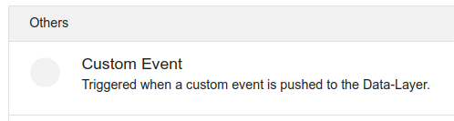
2. We’ll name the Trigger “Purchase Inquiry” and set the Event Name field to the name of the event as seen in the GTM dataLayer
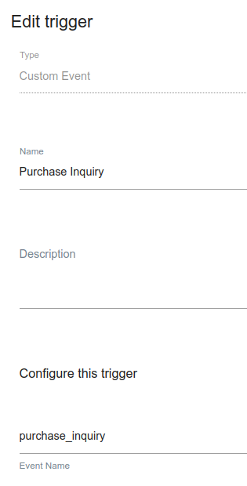

Create a Variable
Next we will create a Variable to capture the aircraft model in order to pass it with the event as the event name:
1. Select Variables -> Create New Variable and choose the ‘Data-Layer’ variable
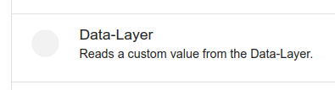
2. We’ll name the Variable ‘Model’ and set the “Data Layer Variable Name” field to the name of the model variable as seen in the GTM dataLayer
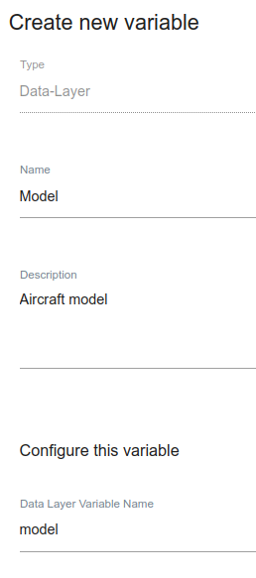

Create a Tag
Now, create a Tag to fire an event when the Trigger is activated:
1. Select Tags -> Create New Tag and choose the ‘Matomo Analytics’ Tag
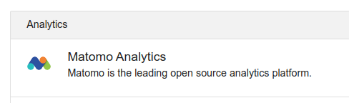
2. In the Tag configuration settings choose tracking type: Event. Then set the event name to the Model Variable we created previously and set the Trigger to the ‘Purchase Inquiry’ created above
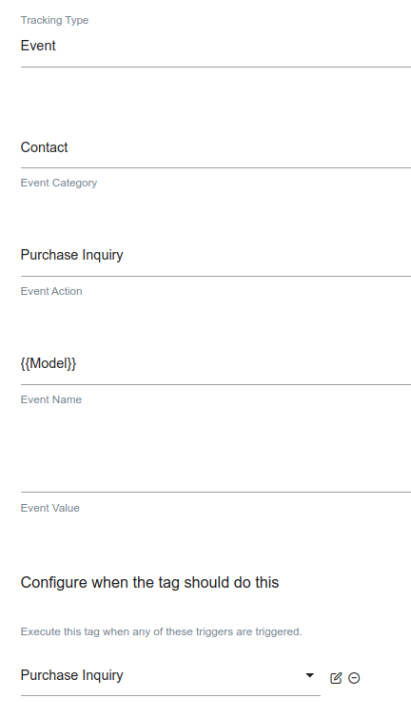

3. Publish the changes you made in this guide to the Matomo Tag Manager container.
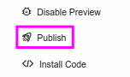
Result:
After publishing your changes to the container, the event will appear in the Overview > Visits Log. Once the reports are processed, the event will also be included in the Behavior > Events section.
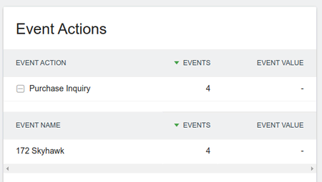

Custom Dimensions and Custom Variables
Tracking custom dimensions involves two main steps. First, you need to create and define the dimension. It's important to plan ahead since you can have only 5-15 custom dimensions per scope (depending on your Matomo version), and typically, dimensions can't be deleted, only deactivated.
The second step is to begin collecting data for the custom dimension. This may require additional custom configuration, depending on the specific data you want to track.
Creating a Custom Dimension: Two Categories
To access the "Manage Custom Dimensions" screen, click on the cog icon in the top right to go to "Administration." In the left menu, you will find the "Custom Dimensions" option. Custom Dimensions can be edited by users with at least 'Write' or 'Admin' access for a specific website. Different Custom Dimensions can be created for each website or apps.
Before creating a new Custom Dimension you have to choose whether you need a new dimension in scope “Visit” or “Action”

Custom Dimensions: Visit Dimensions
Custom Dimensions with the "Visit" scope can be sent with any tracking request and are stored within the visit of a specific visitor. If different values are set for a given "Visit" scope dimension during the course of a visit, the last value set will be used. A common example of this could be device information or the version of the app that the visitor is using.
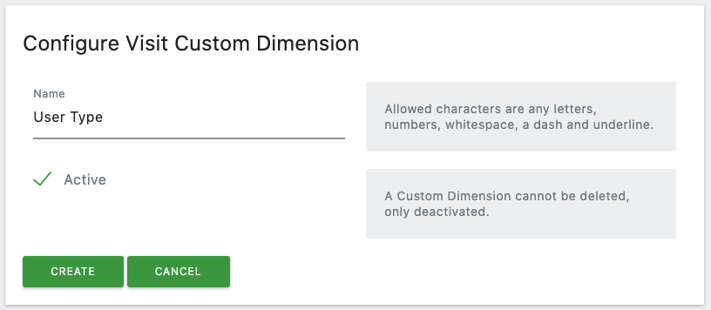
Custom Dimensions: Action Dimensions
Custom Dimensions with the "Action" scope can be sent along with any action, such as a page view, download, or event. A typical use case could be tracking the language of the user for each page view, download, or event.
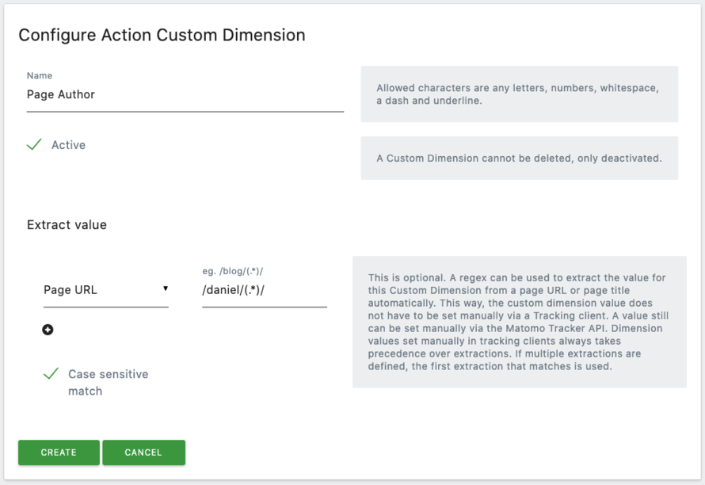
In the Action scope configuration screen, there's an option to set up URL Extractions, allowing you to trigger the tracking of the dimension based on the page the visitor is on. If you don't need this feature, you can leave it unused.
Regardless of the type of custom dimension you create, ensure that the "Active" checkbox is selected, which will display a green tick, and then click the "Create" button to activate the dimension.

Custom Variables
A custom variable is a custom name-value pair that you can assign to your visitors (or page views) using the JavaScript Tracking API, and then visualize the reports of how many visits, conversions, etc. for each custom variable.
A custom variable is defined by a name for example, “User status” and a value – for example, “LoggedIn” or “Anonymous”. You can track by default up to 5 custom variables per visit and/or up to 5 custom variables per page view.
Matomo provides a Custom Variables feature to collect custom metrics for your page views and visits. For example, you can track specific tags associated with a page viewed or the user role of someone navigating your website. This type of data is usually managed through your CMS (Content Management System) and may vary across different sites, so it requires some configuration to get started.
Custom Variables consist of four different elements, all of which are required.
- Index - This is a unique numeric ID which is typically between 1-5 that references the data. You can hold up to 5 custom variables for each scope by default, however if you are using Matomo On-Premise, it is possible to configure it to add more than 5 custom variables for each scope.
- Name - This is a user-friendly label to identify the variable. For example, Tag.
- Value - This is the actual value of the variable. For example, if the variable is tracking tags an article about Matomo could be filed as “Marketing”, “Analytics” or both.
- Scope - This defines whether the variable is page scoped i.e. attached to the page it is loaded on or visit scoped and connected with the visitor that is on the page.
All of the fields are limited to a total of 200 characters.
Custom Variables are a feature available by default in Matomo Cloud, allowing you to track additional, site-specific data that is not captured by standard tracking. These variables are useful for capturing detailed insights about user behavior and interactions on your website or application. For example, you can track things like the logged-in user’s role, the category of a page being viewed, or any other custom information relevant to your business or website.
By using Custom Variables, you can gather tailored metrics for a deeper understanding of user interactions, which can be leveraged for targeted analysis, reporting, or optimization efforts.
In Matomo Cloud, this feature is seamlessly integrated, allowing you to easily configure and start tracking these variables. Unlike self-hosted versions, which may require additional setup or plugins, Matomo Cloud provides the advantage of having Custom Variables readily available for all your sites or applications, simplifying the process of collecting and analyzing custom data.
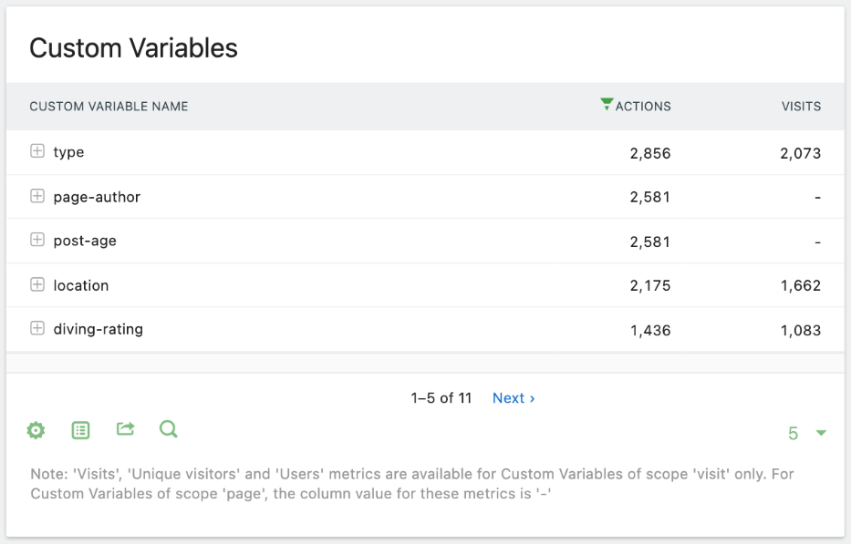

Goal and Conversion Tracking
The Goals feature in Matomo allows you to track your website’s performance against key business objectives, such as lead generation, online sales, and brand visibility.
Goals are crucial for analytics tracking. Clearly defined goals enable you to understand which visitors are converting, the marketing channels driving those conversions, and why some visitors aren’t converting. By analyzing goals, you can identify areas of your website that need improvement to boost conversions. Additionally, goals help pinpoint the most effective marketing channels, allowing you to focus your efforts on what works best.
Each website has specific actions that contribute to achieving these objectives, such as visiting a particular page or submitting a form. Since goals vary from site to site, you’ll need to configure them manually to collect relevant data.
Create a Goal in Matomo
To set up a goal, go to the Goals section in Matomo and click on "Manage Goals." On this page, you'll see any existing goals, along with a large green button labeled "Add A New Goal." Clicking this button will open the "Update Goal" view, where you can enter all the necessary details for your new goal.
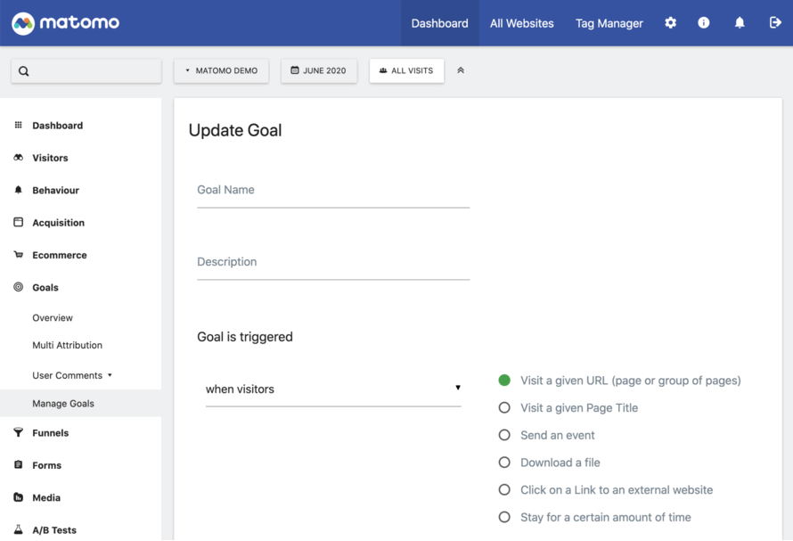
Goal Triggers
There are many actions that can trigger a Goal, however all triggers are set up in one of two ways. The first is by using automatic built-in triggers which you can select while the default when visitor’s option is active. Alternatively, you can set goals to trigger manually. The manual method requires you to add custom JavaScript, which is fired on your website when certain Goal conditions are met.
How to Trigger Goals Automatically “When Visitors” Do Something
Automatic triggers are the simplest method for setting up Goals. There are several of these methods you can use without having to add any additional code to your website. You simply select from the automatic triggers shown on screen:
- Visit a given URL (page or group of pages)
- Visit a given Page Title
- Send an event
- Download a file
- Click on a Link to an external website
- Stay for a certain amount of time
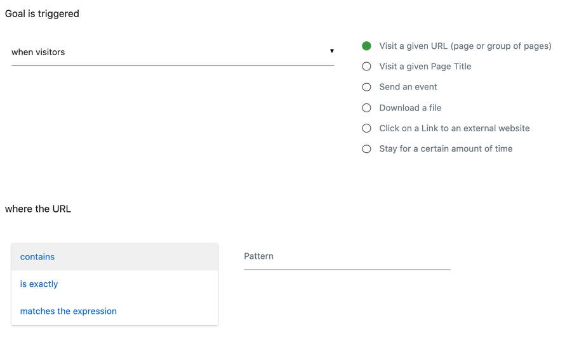
Each of the methods mentioned requires defining a specific action to trigger the goal. For example, when using "Visit a given URL," you can choose from the following options in the dropdown menu and define the filters in the corresponding text box:
- Contains – This triggers the goal when a visitor visits a page where the URL contains the text you enter. This is useful when you want to target a group of similar pages, such as all contact-related pages. For example, typing "contact" would fire the goal when a user visits:
  - https://example.com/contact.html
  - https://example.com/support/contact/
- Is Exactly – This option triggers the goal when a visitor visits an exact URL. For instance, https://example.com/contact/submitted/ might be a page shown after a visitor submits a contact form.
- Matches The Expression – This method uses regular expressions (regex), which provides advanced matching options. It is more complex but allows for greater flexibility. If you're unfamiliar with regex, it's recommended to learn more about it and test patterns thoroughly. For example, a regex like (.)\/contact\/(.) would match any page containing "/contact/" in the URL, such as https://example.com/contact/.
Each of these matching types includes a checkbox to toggle case sensitivity. For instance, if the case sensitivity option is enabled, a goal set to trigger when a page title exactly matches "Contact Us" would not match a page title like "CONTACT US" due to the uppercase letters.
If none of the automatic matching options fit your website's goals, you may need to manually trigger goal completions using JavaScript.
Next, you can decide whether to allow multiple conversions per visit. By default, a goal can only be counted once per visit. This is useful for scenarios like newsletter confirmations, where a user can only register once, even if they load the confirmation page multiple times. On the other hand, for actions like leaving multiple product reviews or applying for multiple jobs, where you want to track each occurrence, you can enable the option to allow multiple goal conversions per visit.

Cross Domain Tracking
Cross-domain tracking in Matomo Analytics enables you to track visitors as they navigate between different domains or subdomains while maintaining the continuity of their session. This is essential when you have multiple related domains or subdomains and want to track them as part of a single user journey, avoiding the fragmentation of visitor sessions into separate entries.
How Cross-Domain Tracking Works in Matomo:
1. Sharing the Visitor ID:
Matomo assigns each visitor a unique identifier stored in a browser cookie. For cross-domain tracking, this visitor ID needs to be passed from one domain to another.
2. Linking the Visitor Across Domains:
When a user clicks a link from one domain to another, Matomo appends the visitor ID and other session-related parameters to the URL as query parameters. The receiving domain reads these parameters and updates its own cookies to match, ensuring session continuity.
3. Tracking Code Configuration:
To enable cross-domain tracking, you need to configure the Matomo tracking code with the list of domains to track. This ensures that Matomo recognizes these domains as part of the same session.
How to setup cross domain tracking:
1. Configure your domain names as Alias URLs for your Matomo website: Login to Matomo and click on Administration > Websites > Manage. Edit your website, and specify all your domain names in the Alias URLs field. There must be two or more domains for cross domain to work.
2. Generate your JavaScript tracker code: In Administration > Websites > Tracking Code, click on “Advanced: Show” link, then check the option “Enable Cross Domain linking” (If this checkbox is not clickable, please check you have defined at least two Alias URLs for this website). This will also automatically check the box “In the ‘Outlinks’ report, hide clicks to known alias URLs”.
3. Check your generated JavaScript tracker code is valid: In the generated Tracking code in Matomo you should see the following two lines:
_paq.push(["setDomains", ["*.domain1.com", "*.domain2.com"]]);
_paq.push(["enableCrossDomainLinking"]);
Note: Be aware that cross-domain linking will not function if cookies are disabled.
Insert the JavaScript tracker code into all the websites you want to measure across domains. For instance, in the example provided, the JavaScript tracker code must be added to both domain1.com and domain2.com. Ensure the code is included on all domains listed as Alias URLs for your Matomo website.
To verify that Cross-Domain linking is functioning correctly, navigate to domain1.com and click a link to domain2.com. If the setup is successful, the URL of domain2.com will include a new parameter, &pk_vid=, containing a string of data that includes the Visitor ID. This mechanism ensures the Visitor ID is passed to the page on the other domain. Similarly, when a user clicks a link from domain2.com to domain1.com, the URL for domain1.com will also include the pk_vid parameter.
Tag Manager Instructions
1. Enable Cross Domain Linking:
- Login to Matomo and click on Tag Manager > Variables and edit the Matomo Configuration variable.
- Scroll down the page and tick the option to enable Cross Domain Linking.
2. Add the domain names to include in your Cross Domain Linking:
- While still editing the Matomo Configuration variable. Scroll down to the “Domains” section and specify all your domain names in the available fields you want to include. Once the changes have been made, click the Update button to save.
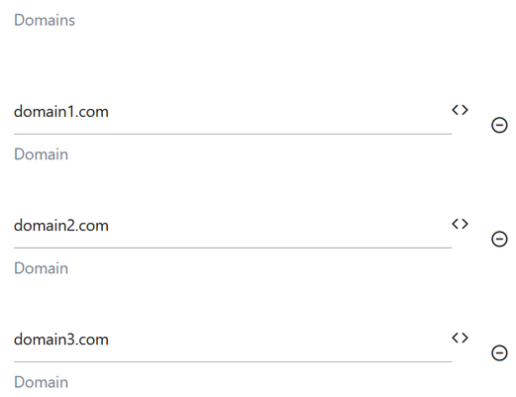
3. Paste the Tag Manager Tracking code into your websites:
- You can find the Tag Manager tracking code from Tag Manager > Install Code.
- The Tag Manager tracking code needs to be added to all the websites you have listed within the “Domains” section of your Matomo Configuration variable in step 2.
4. Check that the Cross Domain linking is working correctly:
- Go to your domain1.com and click on a link to your domain2.com. If Cross Domain linking is enabled and working, the URL of domain2.com will contain a new parameter &pk_vid=. This pk_vid parameter will contain a string of data which includes the Visitor ID. This way the current visitor ID is forwarded to the page of the different domain. Similarly when a user clicks from domain2.com to domain1.com, the domain1.com URL will also have this new pk_vid parameter.

Funnel Analysis
A Funnel represents a series of actions you expect your visitors to take as they navigate your website. For instance, in an e-commerce setting, your primary goal might be for a visitor to complete a purchase, but this often involves several key steps, such as:
- Entering the website
- Clicking on a product page
- Adding a product to their cart
- Proceeding to the checkout page
- Completing the purchase
These steps form a straightforward yet common funnel design. Each step is an opportunity where visitors might exit the funnel. While tracking how many visitors complete a purchase as a primary goal is important, monitoring progression through each step provides deeper insights into where visitors drop off.
The Matomo Funnels feature helps you analyse visitors’ progress through these critical conversion steps. For example, a simplified funnel report might reveal that out of nearly 20,000 website visits, only 1,778 visitors reached the product page, and just 113 completed a purchase. This data highlights where improvements are needed to reduce drop-offs and optimize the funnel for better conversions.
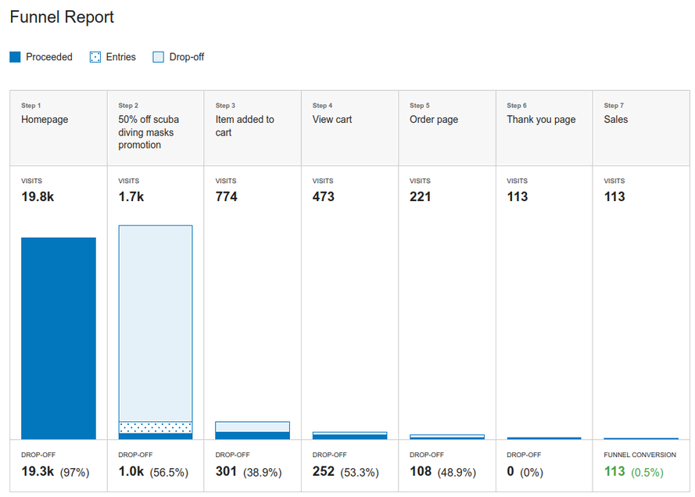
Funnel analysis provides valuable insights into exactly where visitors are dropping off during their journey. With this information, you can focus on optimizing the earlier steps of the funnel to reduce abandonment and improve engagement. By increasing the number of visitors who successfully progress through each step, you enhance the likelihood of conversions at the later stages, ultimately driving better results for your business objectives.
Create funnels analysis
Funnels can be designed to track any sequence of actions across your website. In earlier versions of Matomo (prior to 5.1.0), funnels were required to be linked to a goal. However, this is no longer necessary in newer versions. If you're using an older version, refer to the instructions for creating a funnel associated with a goal.
It's important to note that only users with admin-level access or higher can create or configure funnels in Matomo.
1. Create a funnel without a goal
- Click Manage Funnels under the Funnels section of the side menu.
- Click to Add a New Funnel
- Name the funnel
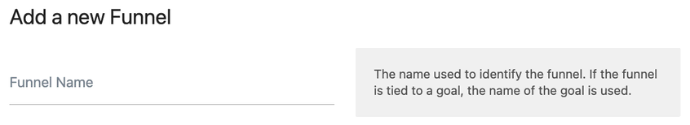
- You can then follow the steps to configure your funnel settings below.
2. Create a funnel linked to a goal
When creating a funnel linked to a goal, start by configuring the goal and then create the associated funnel. The steps for this process are as follows:
- Click the Manage Goals item within the Goals sidebar menu
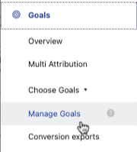
- Once there, you will see a list of goals that you have configured along with a column that shows whether funnel tracking is enabled for each goal or not. If you have no goals yet, you will need to configure one first. Click Add a new goal to configure a funnel tied to a goal.
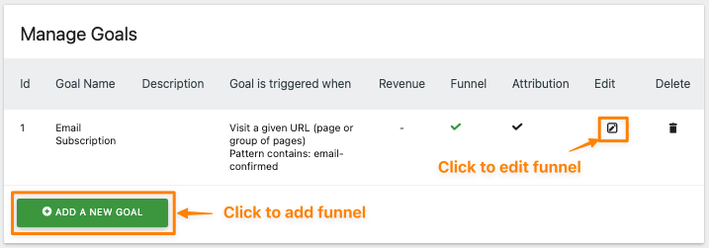
- Once you have configured the goal click the checkbox to Enable Funnel.
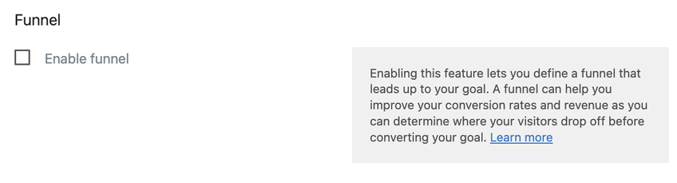
- You can then follow the steps to configure your funnel settings below.
3. Configure your funnel settings
- In the Funnel configuration section, you will need to add each of the steps that make up your funnel. Some examples of common funnel steps are; subscription pages and events, product searches and views, and shopping cart actions.
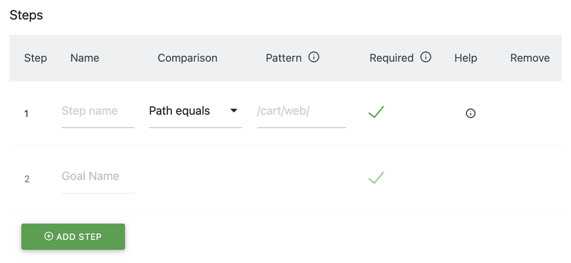
- Configure each step of your funnel as appropriate. There are four components to each step definition:
- Name – This should be something descriptive like Contact Page
- Comparison – Funnel comparison conditions are the same as for goals and use the same selectors as goals. It requires a descriptive Name, a comparison in a similar fashion to your primary goal, and a matching pattern.
- Pattern – The pattern entered here will depend on your comparison selection. For example, if you choose a path or URL option, it will be part of the web address URL for this funnel step. Whereas, if you choose an Event condition, then it should match the event data fired at this funnel step.
- Required – Checking this will mean the funnel won’t be considered complete if a visitor doesn’t pass through this step. For example, you may have a single thank you page, but many different funnels take visitors to it. In that case, you would want to make sure each funnel has a required step before reaching that thank you page to differentiate between your funnel completions.
- Click the Add Step button and repeat instructions 5 and 6 above for as many steps as you have in your funnel.
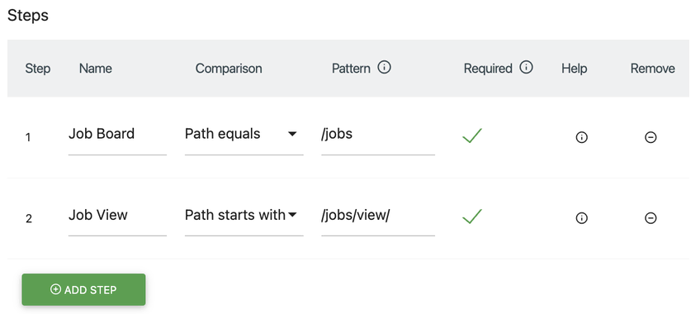
- Once you have entered all of the steps for your funnel, you can use the optional Validate steps section to test if certain URLs match steps of your funnel. When the data you entered matches a step, its background will be highlighted in green, while non-matching steps are highlighted in red. Typically, only one step should match a certain URL or value, as otherwise a visitor would enter multiple steps on one page.
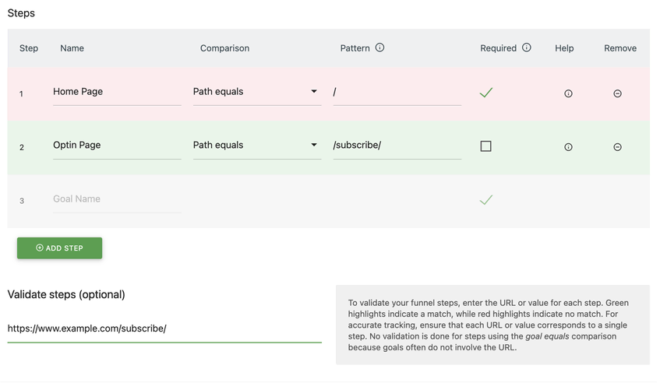
- You can now enable the funnel by clicking the Add Goal or Add Funnel button.
Note: If you are using an older version of Matomo, you will also need to click the Activate Funnel first.
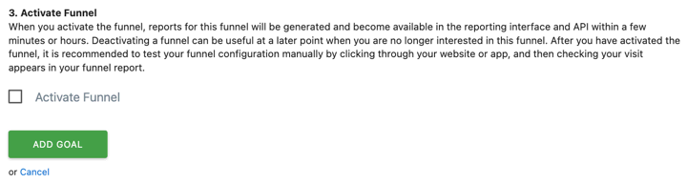
After activating a funnel, Matomo will begin generating reports for it right away, and a dedicated menu item will appear in the reporting interface. If you no longer need the funnel in the future, you can easily return to the Funnels section and delete it.

Segmentation
The Segments functionality in Matomo allows you to break down and analyze your audience by creating smaller, more focused groups based on specific criteria. These criteria could include factors like the visitor's location (e.g., country), device type, behavior (e.g., whether they made a purchase), traffic source, or even the pages they visited. By using segments, you can gain deeper insights into particular user groups, helping you to better understand different behaviours and preferences within your audience. This capability enhances your reporting and helps you make more targeted decisions based on the performance of specific subsets of your users.

Build custom segments in Matomo

1. Open the Segment Editor
To create a new Segment in the Matomo dashboard, click on the button labeled "All Visits" in the data selector section below. The label on this button reflects the current segment, which by default includes all visitors to the site.
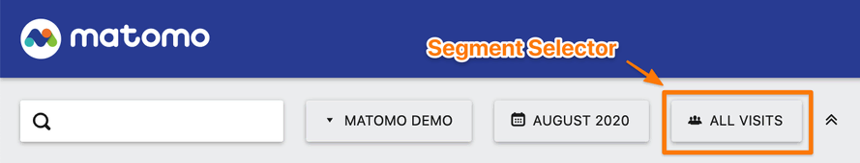
Clicking the segment selector opens a dropdown menu which gives the list of available Segments, including the default All visits, plus any custom segments shared with you or that you’ve created. To start building a new segment, click the big green Add New Segment button which will load the Segment editor.
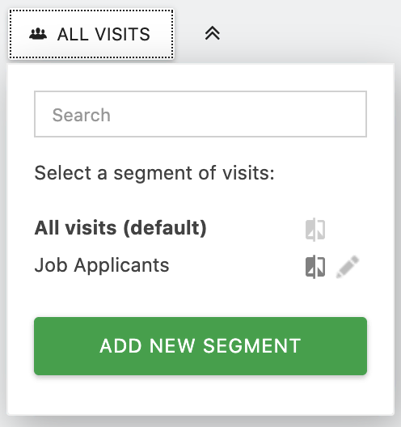
2. Segment Configuration
In the Segment Editor, you'll see a small line of text at the top with dropdowns marked by green arrows. The first dropdown allows you to switch between creating a new segment or editing an existing one. The other dropdowns display the segment configuration settings, with the current settings in bold. While you typically won't need to adjust these, it's helpful to know their purpose and where to find them if necessary.
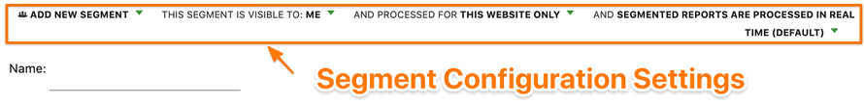
Sharing a Segment with All Users
By default, segments created by a user are only visible to that user and Super Users. When creating a segment, the Segment Editor will display "This segment is visible to me" by default. To share the segment with all users, you can select the option "This segment is visible to all users." Once shared, the segment will be available in the segment list for all users when viewing their Matomo reports. Note: Sharing a segment with all users is restricted to Super Users only.
Reusing Segments Across Other Websites
A segment is initially created for the specific website you're currently viewing. The Segment Editor will show "This segment is processed for this website only" by default. If you want the segment to be available across all websites, you can select the option "This segment is processed across all websites." Once shared, the segment will appear in the segment list on all websites. Note: Sharing a segment across websites is available only to Super Users.
Improving Performance with Segments
Lastly, you will have the option to choose whether segments are processed in real-time or pre-processed (which requires a cron job). This option is only available for self-hosted Matomo instances, as it requires server access. Pre-processing segments is particularly useful for high-traffic sites, as it can help avoid slow loading times for reports caused by the default real-time processing.
3. Defining Your Segment
Next, you can start defining your segment using the editor shown below. Begin by providing a clear and descriptive Name for the segment, which will help you easily identify it later. For instance, you might choose names like Customers or Returning Visitors, as shown in the example below.
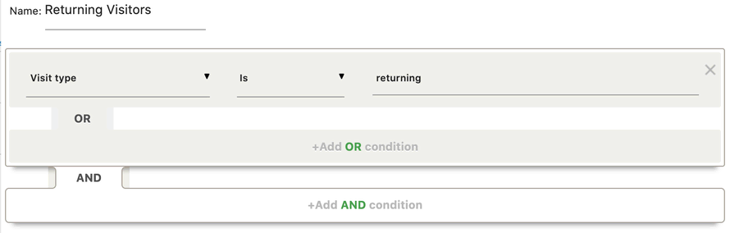
To define the specific group of visitors for your segment, you'll need to create filters based on the data collected from user and visit information. You can also combine multiple filters using logical operators like OR and AND.
To view the available criteria you can use for building your segment, click on the initial dropdown field in the first row. By default, this field will display "Actions in Visit," but clicking on it will open a box with the full list of available criteria to choose from.
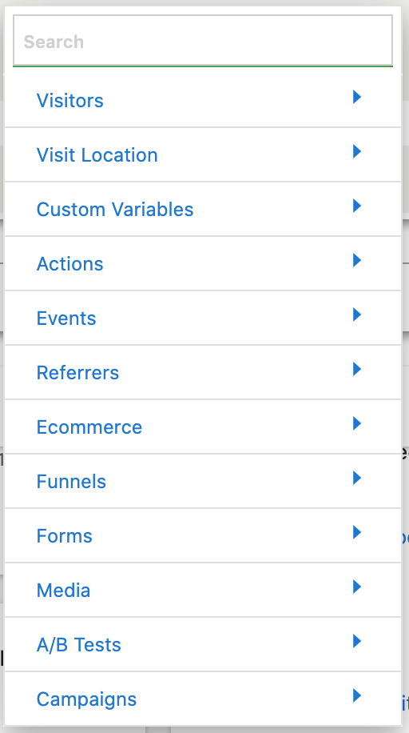
There are numerous filtering options available, so it's worth taking some time to explore the list of segment filters to familiarize you with all the possibilities. If you're already clear on what you want to filter, you can use the search box to quickly find the relevant user or visit data.
After selecting a dimension for your segment, such as "Visit Location > Country" or "Visitors > Visit Type," you'll need to define the filtering criteria. You may notice a small question mark next to many filters. Hovering over these icons will show you a detailed description of the matching criteria for that filter.
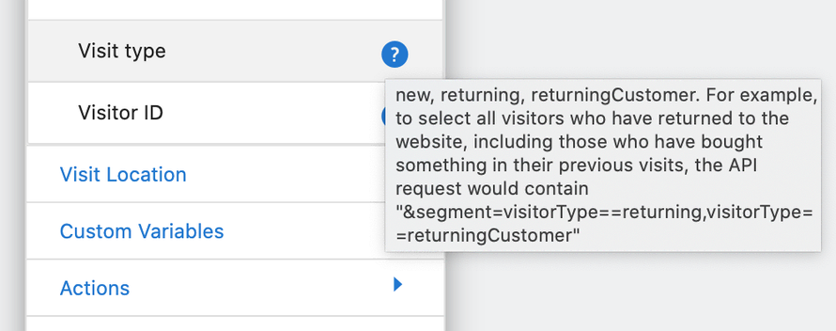
Example:
If you want to create a segment for Returning Visitors from the UK, you would follow these steps:
- Set the first dropdown to "Visit type."
- Set the second dropdown to "Is."
- Set the text box to "Returning."
Next, to refine your segment further:
- Click on "+ Add AND condition" to combine additional filtering options.
- In the new section, set the first dropdown to "Visit Location > Country."
- Set the second dropdown to "Is."
- Set the text box to "United Kingdom."
This configuration will create a segment that includes only visitors who are returning and are from the United Kingdom.
As you start typing a value in one of the text boxes for your filter criteria, Matomo will suggest available options from the dataset. You can click on these suggestions to ensure proper formatting and avoid any potential typos.
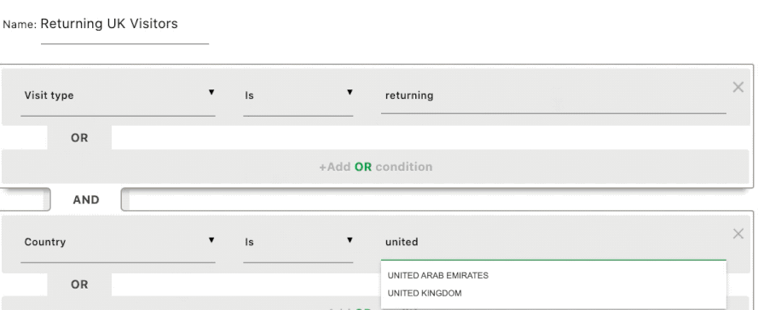
Once you've completed building your filter criteria, you can click the TEST button to view a log of all visits that match your segment. If the details look accurate, you can close the visits log popup and then click the green Save & Apply button at the bottom of the Segment editor to save your segment.

Real-time reports
Matomo provides real-time web analytics reports, including the Visits Log, Real-time Visits, and Real-time Map. When you request data for "today," "current month," or any date range that includes today, these reports will reflect the most recent visits, ensuring you always have access to the latest analytics data.
Additionally, Matomo offers specific tools to help you gain deeper insights into your traffic in real time, allowing you to view data at the individual visit level. These tools enable you to monitor live activity on your website and understand user behavior as it happens.
How to create real-time report
The Visits in Real-time report can be found under Visitors > Real-time and can also be added as a widget in your custom dashboards by going to Dashboard > Add a widget > Visitors > Visits in Real-time. This report provides a live feed of visits to your website, displaying a real-time counter that tracks visits and page views over the last 24 hours and the past 30 minutes.
The Visits in Real-time report updates every 5 seconds and displays new visits (or existing visitors who view a new page) at the top of the list with a fade-in effect. For each visitor, the report shows detailed attributes, such as:
- date
- number of actions
- time spent on the site
- country
- browser
- operating system
- whether the visitor is new or a returning visit
- the referrer used to access your site (Search engine & keyword, Campaign, or Referrer website)
- whether the visitor converted a goal
When you hover over the icons in the Visits in Real-time report, you can view additional details such as the visitor's screen resolution and the list of enabled browser plugins.
The report also includes a list of page views and actions taken by the visitor on your site. Hovering over the page view icon will display the page name and the time at which the page was accessed. If you click on the icon, it will open the actual page on your site, allowing you to view the visitor's interaction in real-time.
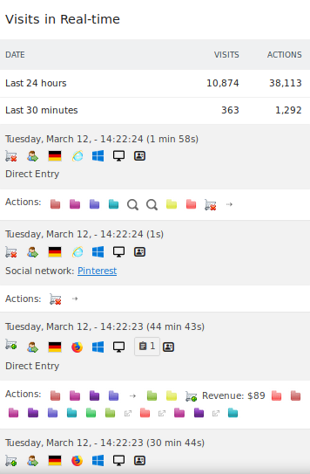

Campaign Tracking
Campaign Tracking is a feature that allows you to log detailed marketing campaign information when linking to your website. This enables you to assess the exact impact of your marketing efforts. It helps track key metrics such as how much traffic is being driven, the level of engagement of those visitors, and whether the campaign is generating sales.
Campaign tracking URLs are commonly used to gather enhanced tracking data from a variety of sources, including:
- Pay-Per-Click (PPC) Ads: Tracking which campaigns and keywords are driving revenue.
- Display and Banner Ads: Identifying which platforms and specific banners are generating traffic.
- Third-Party Marketplaces: Seeing which external listings are referring visitors back to your website.
- Social Networks: Measuring which social media posts are getting the most traction and engagement.
- Email Newsletters: Determining which newsletter campaigns are driving traffic and leading to sales.
- Guest Blog Posts: Tracking which external content and blog posts attract the most website visitors.
By using campaign tracking URLs, you can gain valuable insights into the performance of your marketing strategies and optimize future campaigns accordingly.
How to build campaign tracking URLs
Campaign Tracking URLs help you track the performance of marketing campaigns by appending specific parameters to your website URL. These URLs can be created manually, but the easiest method is using a URL builder tool.
Matomo provides a Campaign URL Builder within its platform, where you can enter details such as the website URL, campaign source, medium, name, and optional terms or content. The tool then generates a tracking URL that can be used for accurate campaign performance tracking, ensuring proper formatting and reducing errors.
Matomo Campaign URL Builder
- Log in to your Matomo instance and click on the Acquisition section.
- Click on Campaign URL Builder sub-menu item.
- Copy the URL from your website that you would like to create a tracked link for.
- Paste the copied link into the Page URL (Required) field.
- Add any required and desired campaign values in the remaining fields. In the grey box alongside each field, there is a description of what it should include, along with examples.
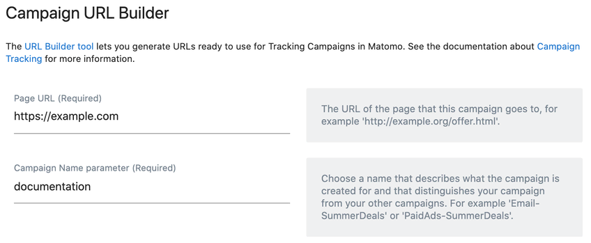
- Click the big green Generate URL button at the bottom of the page.
- Copy the generated URL from the grey box below and use it wherever you are running your campaign, for example, in an email or a third-party marketplace.
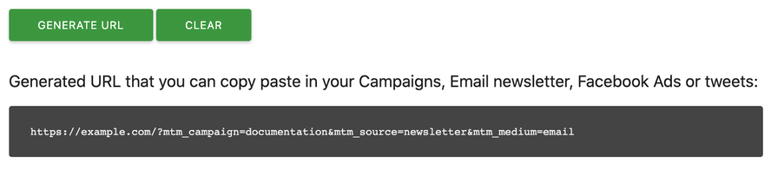
Important Note: Simply generating a tracked URL is not enough; you must actually use the generated link in your campaigns for it to be effective. Campaign links only provide value when users click on them, so be sure to embed the tracked URL within your digital marketing efforts to track the campaign's performance accurately.
Select appropriate campaign values
While you can type almost anything as values for each of the campaign tracking elements, you will want to plan ahead to ensure they are useful. In general, you want to make sure that you use descriptive human-readable values so you will be able to easily identify them when reviewing your analytics.
There are a few considerations which may not be immediately apparent.
- Campaign values are stored in lowercase – For consistency, don’t use capital letters when creating your campaign tracking values.
- Special characters may not work – If you want to use special characters such as a forward slash in your value, you will need to encode it for use within a URL. As an example, to include a forward slash in your campaign values, it would need to be typed as %2F within your URL.
- Don’t use spaces – This is also related to URL encoding. The space character will often break links. Many people choose to use underscores or dashes to represent spaces instead. Although, you can also encode spaces for URL usage by typing %20. For example, if you were creating a tracked link for a “brand awareness” campaign, you might use:
  - brand%20awareness – Displayed as brand awareness in your analytics
  - brand_awareness – Displayed as brand_awareness in your analytics
  - brand-awareness – Displayed as brand-awareness in your analytics
Whatever method you choose, it is important to be consistent, otherwise, you will find your traffic split between multiple variations of the same campaign, which can make accurate reporting harder.
- Campaign tracking values are visible – One final consideration is that all of the campaign values are visible to the end-user. This may seem obvious, but it also means that people may notice the values when visiting your website. Make sure you choose values that you are happy for the public to see and avoid including any personal data or personally identifiable information (PII) within your URLs.
You may not want to use the following URL, for example:
https://example.com/?mtm_campaign=secret_list&utm_source=private_supplier&utm_content=john_smith

Reports and Dashboards
Custom Reports is a premium feature available with the Cloud-hosted Business plan or through a separate purchase on the Matomo Marketplace. This feature provides you with complete ownership and control over your data, allowing you to create tailored reports that meet your specific needs.
To access the ‘Manage Custom Reports’ screen in Matomo:
- Navigate to the ‘Custom Reports‘ option located in the left menu or the Administration menu(cog icon).
- Select ‘Manage Reports‘ to enter the custom report management interface.
The main navigation section on the left-hand side of the Matomo interface is your primary method for navigating through your data. The key sections which we will describe in more detail below are listed in bold. Clicking on the top-level item for this section reloads the page and brings up a sub-menu containing the rest of the items for this section.
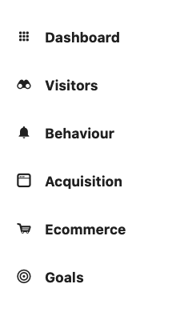
Dashboards
To access your Dashboards, click on the Dashboard link in the blue top menu. Then click the Dashboard menu item within the main navigation on the left-hand side.
Inside that section, you will see a list of available dashboards including a default which is appropriately called Dashboard. If you have created, or have access to, any custom dashboards, you will see them listed below.
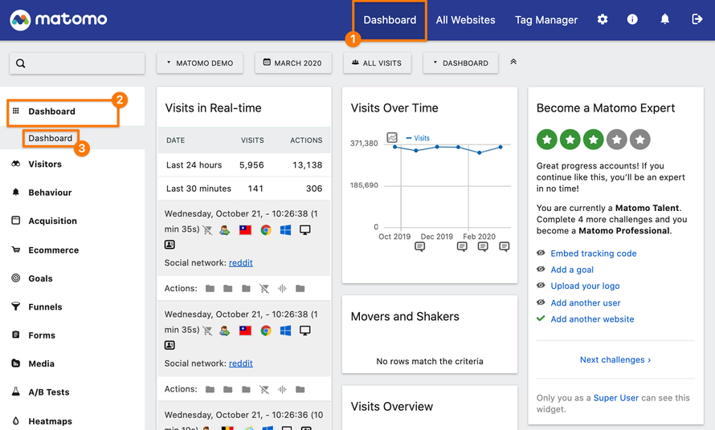
Note: If you have more than five dashboards, only the currently selected dashboard name will be visible, with a dropdown arrow next to it. Clicking on the dashboard name will display the full list of dashboards. Additionally, there is a search bar to help you quickly find a specific dashboard.
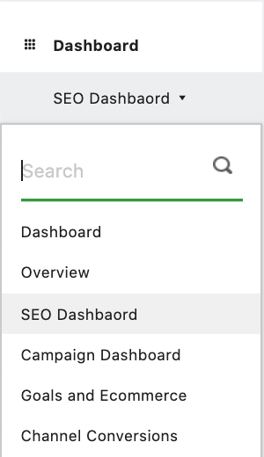

Attribution Tracking
Attribution tracking allows you to measure each channel’s ROI and identify how much each channel impacted your campaigns.
It gives you a more accurate picture of the performance of each channel and each campaign.
Creating attribution reports in Matomo can help you understand which marketing channels and campaigns are driving conversions, allowing you to optimize your marketing efforts. Here's a step-by-step guide on how to create attribution reports in Matomo:
1. Enable Attribution Feature
- Attribution reports in Matomo require you to have access to the Attribution plugin, which is a premium feature. If you don't have this enabled, you will need to subscribe to a plan that includes it, such as the Matomo Cloud Business Plan or purchase the plugin from the Matomo Marketplace.
2. Access the Attribution Plugin
- Once the Attribution feature is enabled, navigate to Attribution in the left-hand menu.
- This will bring up the Attribution Report page, where you can analyse the contribution of different marketing channels, campaigns, or sources to your website's conversions.

3. Select the Attribution Model
The following attribution models are available within Matomo:
- Last Interaction: The full credit of a conversion goes to the last interaction.
- Last Non-Direct Interaction: The full credit of a conversion goes to the last interaction that was not a direct entry.
- First Interaction: The full credit of a conversion goes to the first interaction.
- Linear: The credit of a conversion is shared equally across all interactions. If there are for example 5 visits, each channel / referrer gets 20% of the credit.
- Position Based: The first and the last interaction get each 40% of the credit. The remaining 20% of the credit are shared equally across all remaining interactions.
- Time Decay: The credit of a conversion is shared across all interactions where more recent interactions become more credit compared to interactions that happened a longer time ago.
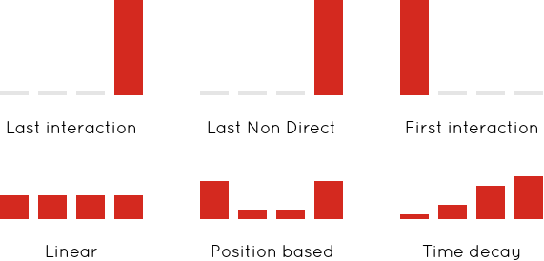
4. Set up Attribution Reporting Criteria
- You can filter attribution reports by various criteria such as:
  - Campaign: See the attribution by specific marketing campaigns.
  - Source: Analyse which traffic sources are contributing to conversions.
  - Medium: Check attribution by different marketing mediums (e.g., paid search, email, social media).
  - Keyword: Track the impact of specific keywords if you are running search engine campaigns.
- Apply these filters to narrow down the data for more precise insights.
5. Choose the Time Period
- Select the timeframe for your attribution analysis, such as today, this week, last month, or a custom date range.
6. Review and Interpret the Data
- The attribution report will show how various channels, campaigns, or sources contribute to conversions, based on the selected attribution model.
- You can see data like:
  - Number of conversions (or goals completed)
  - Revenue (if you have ecommerce tracking set up)
  - Number of visits or interactions with each channel
- This helps you understand which channels are more effective in driving conversions.
7. Monitor and Optimize
- Regularly monitor the attribution reports to evaluate the performance of your marketing channels and campaigns. Use this data to allocate your budget and resources to the most effective channels, driving higher conversions and better ROI.
By following these steps, you can create and customize attribution reports in Matomo, helping you make data-driven decisions about your marketing strategy.

Data Sampling
With Matomo, you’re guaranteed 100% accurate data. Matomo doesn’t use data sampling on any of our plans compared to free Google Analytics (which has a threshold on how much data is analysed).
With GA, your data is subject to the following general thresholds for sampling:
- Free GA: 500k sessions at the property level for the date range you are using
- GA 360: 100M sessions at the view level for the date range you are using
Example:
GA then starts to sample all the data that’s collected after that data cap. E.g. when you collect 5 million page views or more – only 500K of that 5 million is accurate. The data for the remaining 4.5 million (90%) is an assumption based on the 500K sample size.
Google puts you at a disadvantage as you have to pay $150K/year for their GA360 suite just to get accurate reporting.

Data Privacy and Compliance
What is Google Consent Mode, and why is it generating so much attention among analysts and marketers? This question has been a focal point of discussion since early this year.
Google Consent Mode is a solution designed to help websites manage data collection in compliance with user privacy regulations.
It allows website owners to adjust how Google tags (such as those for Google Analytics or Ads) behave based on users' consent preferences for cookies. This ensures adherence to privacy laws like GDPR in Europe and CCPA in California while minimizing the loss of valuable analytical insights.
Consent Mode
Consent Mode v1 has become the current standard indicating the incorporation of four consent types:
- ad_storage: allows for the collection and storage of data necessary for delivering personalised ads based on user actions.
- ad_user_data: pertains to the collection and usage of data that can be associated with the user for ad customisation and optimisation.
- ad_personalization: permits the use of user data for ad personalisation and providing more relevant content.
- analytics_storage: relates to the collection and storage of data for analytics, enabling websites to analyse user behaviour and enhance user experience.
Additionally, in Consent Mode v1, there are two modes:
- Basic Consent Mode: in which Google tags are not used for personalised advertising and measurements if consent is not obtained.
- Advanced Consent Mode: allows Google tags to utilise anonymised data for personalised advertising campaigns and measurements, even if consent is not obtained.
Consent Mode V2
Consent Mode v2 is an improved version of the original Consent Mode, offering enhanced customisation capabilities and better compliance with privacy requirements.
The new version introduces additional consent configuration parameters, allowing for even more precise control over which data is collected and how it’s used. The key difference between Consent Mode v2 and Consent Mode v1 lies in more granular consent management, making this tool even more flexible and powerful in safeguarding personal data.
In Consent Mode v2, the existing markers (ad_storage and analytics_storage) are accompanied by two new markers:
- ad_user_data – does the user agree to their personal data being utilized for advertising purposes?
- ad_personalization – does the user agree to their data being employed for remarketing?
How to implement Consent Mode V2
The implementation of Google Consent Mode v2 has encountered several challenges and bugs, which is not unexpected. Here's what you need to know:
1. Essential for EU Traffic with Google Ads
- Advanced Consent Mode v2 is crucial if your website relies on traffic and campaigns from Google Ads in the European Union.
2. Impact on Traffic Reporting
- If your website does not generate substantial traffic, enabling Advanced Consent Mode v2 could lead to a noticeable drop in reported traffic in GA4.
- Unlike the basic version, Advanced Consent Mode v2 uses behavioural modelling for users who have declined cookie tracking, but this process takes time to yield results.
3. Behavioural Modelling Requirements
- When users decline tracking, their behavior is modeled using machine learning.
- However, the success of modeling relies on sufficient data volume.
- According to Google’s documentation, at least:
  - 1,000 daily events with analytics_storage='denied' are needed for 7 consecutive days.
  - 1,000 daily users with analytics_storage='granted' are required for at least 7 days within a 28-day period.
Market Response
The rollout of Consent Mode v2 has received mixed reactions:
- Many marketers have reported significant traffic drops in their GA4 and Google Ads reports after enabling Advanced Consent Mode.
- This occurs because Google’s behavioural models fail to generate accurate data when there isn’t enough input data for training.
Common Observations
Websites with low traffic volume face challenges with behavior modeling, leading to dramatic drops (90-95%) in metrics like users and sessions in GA4 and Google Ads reports.
Summary
Switching to Google Consent Mode v2 requires careful consideration. If your website doesn’t have the traffic volume needed to support behavioural modeling, you should be prepared for substantial data losses in your analytics and ad performance metrics.
Cookie Behaviour
Adjusting cookie behavior in Matomo allows you to align your analytics setup with user privacy requirements and customize how cookies are used on your website. Here's how you can manage and adjust cookie behavior in Matomo:
1. Accessing the Cookie Settings
- Log in to your Matomo dashboard.
- Navigate to Settings > Privacy > Cookies.
2. Managing Cookies in Matomo
Matomo provides several options to adjust cookie behavior:
a. Disable Cookies Entirely
- If you do not want to use cookies at all (e.g., to comply with certain privacy regulations):
  - Go to the Cookies section.
  - Enable the option to Disable all cookies.
Note: Disabling cookies may affect tracking accuracy, as Matomo will rely on server logs or other non-cookie methods to identify users.
b. Set Custom Cookie Expiry
- You can adjust the expiration time for Matomo cookies:
  - Choose different durations for visitor cookies (_pk_id) and session cookies (_pk_ses).
  - Reduce the expiry time to minimize the amount of data stored.

c. Opt-Out Cookie
- Allow users to opt out of being tracked by setting an opt-out cookie:
  - Go to Privacy > User Opt-out.
  - Embed the opt-out form on your website to let visitors disable tracking.
3. Anonymize Data
To further align with privacy regulations, you can configure Matomo to anonymize user data while still using cookies:
- Enable IP Anonymization: Remove part of the user's IP address (e.g., the last octet).
- Disable or minimize the use of personally identifiable information (PII).
4. Enable Consent Tracking
- If you want to respect user consent before setting cookies:
  - Use Matomo's Consent Manager to enable tracking only after users have granted explicit consent.
  - Implement the requireConsent () JavaScript API in your website's tag to delay cookies until consent is obtained.
5. Use a Cookie-less Tracking Approach
- For websites needing strict compliance with regulations like GDPR, you can enable cookie-less tracking:
  - Matomo will track users based on server-side logs, device fingerprints, or other methods that don’t involve storing cookies.
6. Third-Party Cookies
- Disable third-party cookies to ensure Matomo only uses first-party cookies:
  - This prevents data sharing across domains and improves privacy compliance.
7. Review Cookies via Browser
You can verify the cookie settings on your website:
- Use browser developer tools (e.g., Chrome DevTools) to inspect the cookies being set by Matomo.
- Adjust settings further if unnecessary or non-compliant cookies are detected.
8. Save and Test Settings
- After making changes, save your settings.
- Test your website's behavior to ensure cookies are adjusted as expected and compliance goals are met.

Custom Alerts
Custom alerts help you stay informed about your website's activity without the need to monitor data daily. They allow you to set up notifications for any report, triggering alerts when specific conditions are met or not met.
Managing your Custom Alerts
To manage your Custom Alerts:
  - Click on “Administration”
  - Click on “Alerts” under “Personal” in the left menu
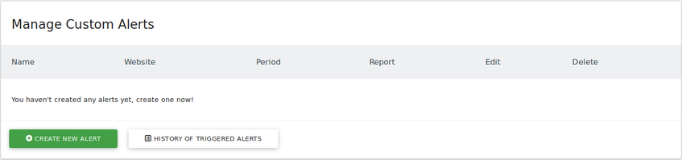
Creating an alert
To create a Custom Alert:
  - Click on “Administration”
  - Click on “Alerts” under “Personal” in the left menu
  - Click on “Create New Alert”
  - Choose a name for your Alert
  - Choose a Website from the dropdown under “Apply To”
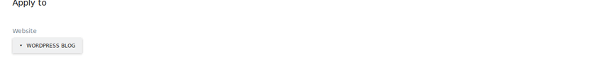
  - Choose the period for when any alert conditions should be checked (alert condition will be checked around midnight on the period of your selection)
- Available periods to choose from:
    - Day – Sent every day around midnight
    - Week – Sent every Monday around midnight
    - Month – Sent every 1st of the month around midnight
  - Choose the recipient of the Custom Alert, this can email or SMS. Phone numbers will only be listed if you have configured SMS gateway
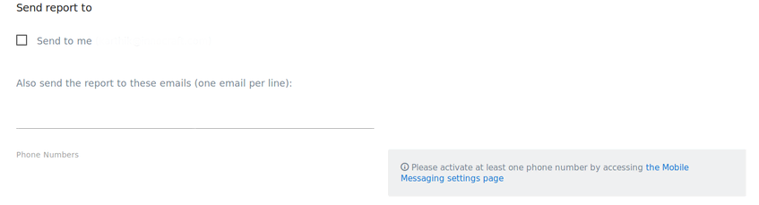
  - Choose the report under “Alert Condition” you would like to monitor
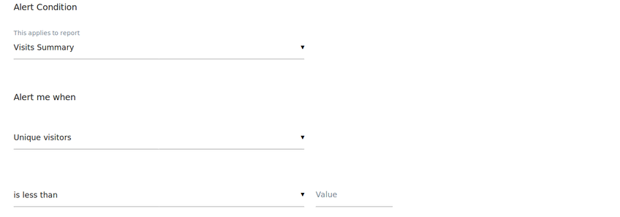

Key Information about Alert Conditions
The Alert Condition section is a crucial part of configuring Custom Alerts. Here, you can specify the report you want to monitor. With over 70 reports available to choose from, you can refer to our Analytics Terms Glossary for a comprehensive list of options.
List of Operators
- matches any (if you choose this, the “Alert me when” conditions will be checked against all rows of your report)
- is
- is not
- matches regular expression
- does not match regular expression
- contains
- does not contain
- starts with
- does not start with
- ends with
- does not end with
By using these operators, you can set up alerts based on the label of a specific row in your report. The value field allows you to specify which row's label you want to monitor.

Example: If your homepage is titled "Home," and you'd like to be notified when its metrics exceed or fall below a certain threshold (or when they increase or decrease by a specific value), you would configure the alert to trigger when the Page Title is set to "Home."
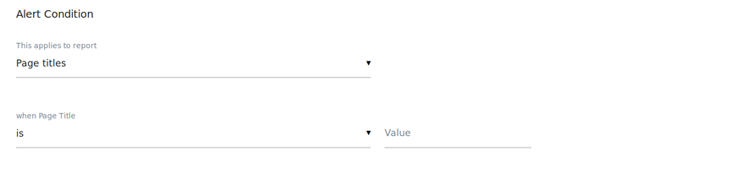
Key Details About the "Alert Me When" Section
This section allows you to define which metric you want to monitor and the specific changes in this metric that will trigger your custom alert. The metrics available for selection will depend on the report chosen in the “This applies to report” field.
List of Available Operators:
- is less than
- is greater than
- decreases more than
- increases more than
- % decreases more than
- % increases more than
Example:
If you want to monitor the pageviews for your homepage (titled "Home"), you would:
- Select Pageviews as the metric.
- Choose an operator, such as "is greater than" or "increases more than."
- Set the threshold value that will trigger the alert.
This configuration ensures you’re notified whenever the specified condition for the chosen metric is met.
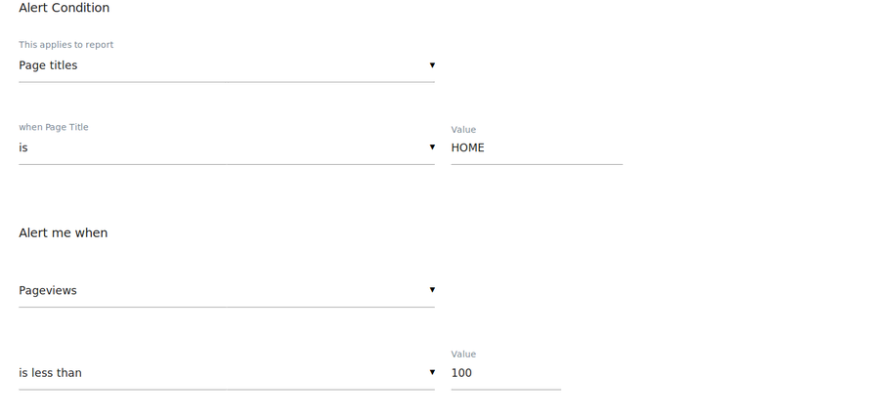
Heatmaps and Session Recording
Heatmaps allow you to track and analyze visitor interactions on your website, including clicks, mouse movements, and scrolling activity. They help you uncover areas where users mistakenly believe something is clickable, identify parts of the page that receive little attention, understand what visitors are actively seeking, and determine how much of the page is visible during their visit. By using Heatmaps, you can optimize your website’s design and functionality to improve user experience and achieve greater success.
To generate a heatmap, log in to your Matomo (Piwik) and click on “Heatmaps => Manage” either in the reporting menu or the administration menu.
Create and manage heatmaps
To start recording user interactions and generating heatmaps for your pages, you first need to create a Heatmap.
Access the “Manage Heatmaps” screen by selecting “Heatmaps” and then “Manage” from either the reporting or administration menu. No coding skills are required, and there’s no need to modify your website’s code. The interface provides clear, detailed guidance for each step, making it quick and easy to configure heatmaps and track user interactions.
To create a new heatmap, click “Create new heatmap” at the bottom left of the screen. To edit an existing heatmap, simply click the “edit” icon next to the heatmap’s name.
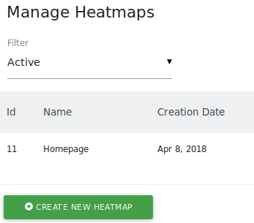
When you create or edit a heatmap, all you need to do is define a name for the heatmap and choose on which target page the heatmap should be generated for. To do this, you can choose between “URL”, “URL path”, “URL parameter” attributes and comparisons like “equals”, “starts with”, “contains”, “matches the regular expression”, and many more. The validator next to your target page lets you easily test whether the page you want to match actually matches the Pages for which you want to generate Heatmaps.

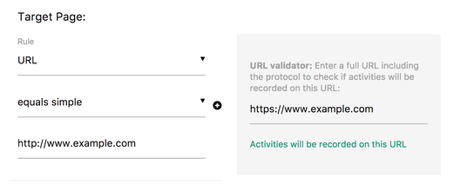
Advanced options
When you configure a heatmap, you can optionally define advanced options such as:
- choose a Screenshot URL
- hide elements from the heatmap
- choose a different Sample rate
- define the Breakpoint width for Mobile phones and Tablet (useful if your website is responsive)
As always, the meaning of each option is clearly explained in the user interface.
Example
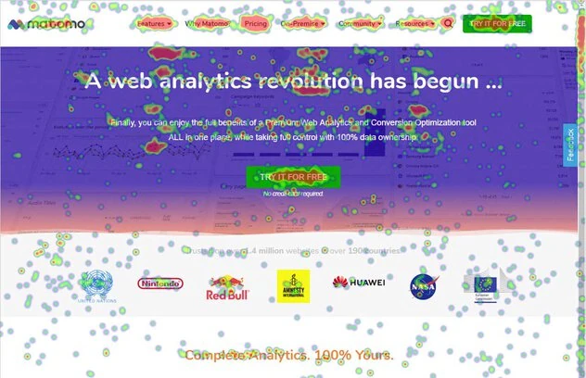
Session Recording
Session Recordings allow you to capture and record real visitor activities on a webpage, including clicks, mouse movements, scrolling, window resizing, page navigation, and form interactions. These interactions can then be replayed as a video, giving you a clear view of how visitors engage with your website. This helps you gain valuable insights into their expectations, challenges, and usage patterns, enabling you to optimize your site and improve overall success.
To record sessions, log in to your Matomo and click on “Session Recordings => Manage” either in the reporting menu or the administration menu.
Create and manage session recordings
Before recording user sessions, you need to create a session recording.
To access the "Manage Session Recordings" screen, navigate to "Session Recordings" via either the reporting or administration menu and select "Manage." Configuring session recordings requires no developer expertise or website code adjustments. The user interface provides detailed explanations for each step, enabling you to set up session recordings in just a few seconds.
Creating and editing a session recording
To record new sessions, click on “Create new session recording” in the bottom left. To edit a session recording, simply click on the “edit” icon next to the name of a previously created recording.
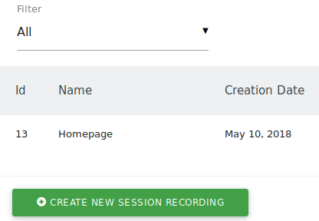
When you create or edit a session recording, all you need to do is defining a name for the recording. That’s it. Optionally, you can choose to record activities only on a specific target page or target pages. To do this, you can choose between “URL”, “URL path”, “URL parameter” attributes and comparisons like “equals”, “starts with”, “contains”, “matches the regular expression”, and many more. The validator next to your target page lets you easily test whether the page you want to match actually matches the Pages on which you want to record your user’s sessions.
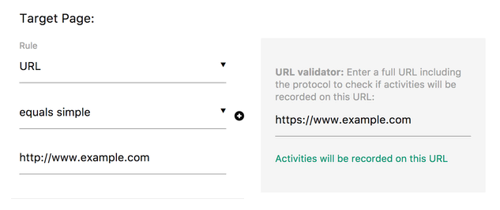
Advanced Options
When setting up a session recording, you can customize the configuration with advanced options, including:
- Requires activity: Record a session only if the user clicks and scrolls.
- Min Session Time: Record sessions only if the user spends a minimum amount of time on your webpage.
- Capture keystrokes: Optionally disable recording of keystrokes entered into text form fields.
- Number of sessions: Specify the total number of sessions to record.
- Sample Rate: Determine the likelihood of a user being recorded.
Each option is clearly explained within the user interface to simplify configuration.
Session Recording Report
A session recording report shows you a list of all recorded page views including useful information like the time of the page view, the duration of the page view, the viewport resolution, the location, device information, and more.
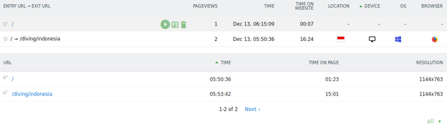
To replay a recorded page view, to delete a recording, or to view the visitor profile, hover a row and select a row action.
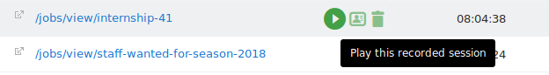
Applying segments
If you have recorded many sessions and want to slice and dice your visitors, you can apply any of over 100 Matomo (Piwik) segments to find the recorded sessions of a specific target groups.
Replaying a recorded session
To replay a recorded session, hover a row in the session recording report and click on the play icon. A new window will open with a video player and automatically start replaying the session. You can pause the video at any time and jump to a specific position by either clicking on the timeline or by using one of the keyboard shortcuts.
Below the video timeline you will see the screen the same way the recorded visitor did. The video will show the mouse pointer and mouse movement path. Circles will show you where a user clicked. If the user scrolled, resized the window, if a pop-up appeared, or made changes in a form, you will see the same actions replayed in this video.
Example:

Playing a recorded session from the Visits Log
When you browse your Visits Log, a link “Replay recorded session” will appear at the top of each visit which was recorded. Clicking on the link will open and play the visitor’s session video in a new window.
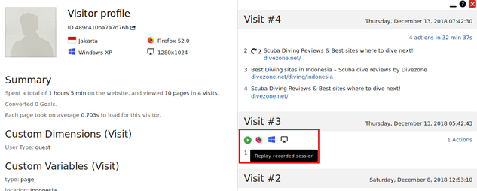
Offline Data Integration and Report
The Matomo JavaScript tracker allows you to track users while they are offline and automatically execute tracking requests once they are online. This feature is particularly useful for Progressive Web Apps (PWAs). To utilize this functionality, follow the steps below.
Step 1. Create a file for the service worker
If you don’t have a service worker yet, then you need to create a file for your service worker in the root directory of your website. In below example we assume the file is called service-worker.js.

Step 2. Register service worker
If you have not registered a service worker yet, register your service worker like this in your website:
Snippet Code:
if ('serviceWorker' in navigator) {
window.addEventListener('load', function() {
// adjust `service-worker.js` to match the file name of your worker
navigator.serviceWorker.register('/service-worker.js');
});
}
Every page where you want to utilise offline tracking needs to include this snippet.
Step 3. Initialise offline tracking
Within your service worker (for example in your service-worker.js) add this code:
// replace `https://your.matomo.domain` with the domain and path to your Matomo installation
self.importScripts('https://your.matomo.domain/offline-service-worker.js');
matomoAnalytics.initialize();
The method initialize supports currently these options:
- queueLimit: Defaults to 50 and defines how many requests will be queued max while a user is offline. If more requests than the configured limit are queued, the oldest requests will be removed.
- timeLimit: Defaults to 86400 seconds (1 day) and specifies after how many seconds the tracking requests should be disregarded if the user does not come online. This is set to 1 day because the Matomo tracker API requires authentication should you try to record a tracking request for more than a day in the past. If you want to keep the requests for more than one day, you will need to change this setting and also configure the time after which Matomo tracking requests require authentication.
Example: matomoAnalytics.initialize({queueLimit: 100, timeLimit: 86400*2});
Known Limitations: Currently, only the standard tracking endpoints are supported, including matomo.js, piwik.js, matomo.php, and piwik.php. Custom paths, such as tracker.js and tracker.php, are not yet supported.
Offline Data Tracking Report
1. Ensure Offline Data Tracking is Set Up
- Offline Data Tracking is typically used for tracking events that happen offline, such as sales or interactions that occur in physical stores or over the phone. This requires using Matomo's Measurement Protocol or importing data manually through CSV files or API.
- Make sure your Matomo installation is configured to handle offline data, either through custom integrations or offline event imports.
2. Navigate to the Reports Section
- Once the offline data is successfully recorded in Matomo (via the API or manual import), you can view it through the regular reports section in the Matomo dashboard.
Steps:
- Log into your Matomo dashboard.
- Navigate to the Visitors section in the main menu.
- Depending on your offline tracking setup, check the relevant sub-sections, such as Event Tracking or Custom Variables, to find the offline data reports.
3. View Imported Offline Data
- If you manually import offline data (such as sales, leads, etc.), it will appear in reports like Custom Events, Custom Dimensions, or Custom Metrics, depending on how the data is structured and imported.
4. Use Matomo’s API for Advanced Offline Tracking
- For more complex offline tracking, you can use the Matomo API to send offline data programmatically. Once the data is sent and processed, it will appear in your reports under the respective categories.
- The API endpoint for offline tracking is usually related to Events, Goals, or Conversions, depending on how you have set up your tracking.
Important Points
- Offline tracking data needs to be collected using Measurement Protocol or imported manually.
- Once data is imported, it will appear in the usual reports under Visitors > Events, Goals, or Custom Reports.
- You can use the API for automated and more flexible offline tracking.

Data Dictionary and Combine data from different source
At the moment, there isn't much documentation or built-in functionality in Matomo specifically dedicated to creating or managing a data dictionary. A data dictionary typically refers to a comprehensive list or catalog of data elements, such as variables, metrics, and dimensions, used within a system, along with descriptions, data types, and relationships.
While Matomo doesn’t offer an out-of-the-box data dictionary tool, using a simple spreadsheet or a documentation platform to manually track this information could be beneficial, especially for teams working collaboratively on analytics or looking to standardize their data definitions across reports.
Combine data from different Matomo instances in Looker Studio
This is currently not easily achievable. However, it is possible if you are ok with creating multiple Google accounts, one per Matomo instance.
Begin by creating data sources for each Matomo instance within each of your Google accounts. Then visit the Data sources tab in each Looker Studio dashboard and click the more icon represented by three dots at the end of the row for your Matomo data source.
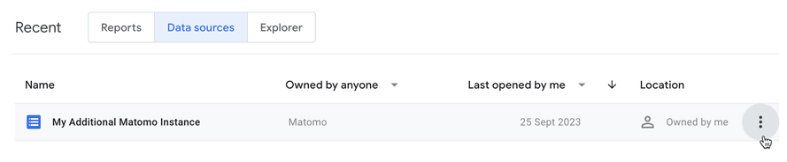
Then click Share within the sub-menu and invite your primary Google account to use the data source.
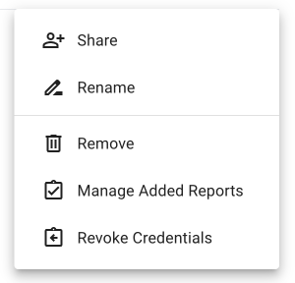
Repeat this process for each additional Matomo instance within each additional Google account.
Once your primary account has been invited to share all of the Data sources from the additional accounts, you can then use the primary account to create reports using the additional shared data sources for multiple Matomo instances.

Data Export
To export data from Matomo, follow these steps:
- Choose the desired date range by clicking on the calendar icon.
- Open the report you wish to export data from.
- Hover over the report: icons will appear in the footer beneath the report.
- Click on the “Export this dataset in other formats” icon in the footer to export the data.
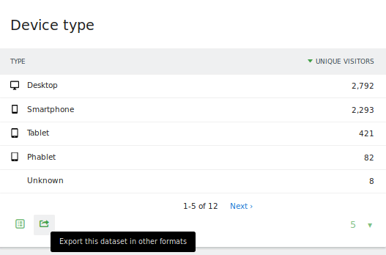
- Choose your export format (CSV, JSON, XML, RSS, HTML), report type (Standard or Metadata report), the report row limit, and click the “Export” button to download your report data.
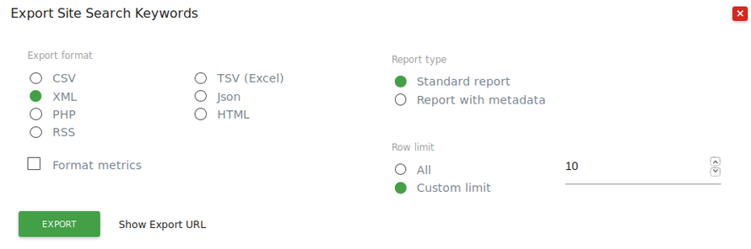

Data Visualization
The primary reporting area in Matomo allows you to review your data across different sections of the main navigation. The analytics data in the Matomo reporting interface is presented through four main visualizations Evolution Graph, Table, Sparkline Summary Cards, and Maps. Each of these visualizations is explained in more detail below.
1. Evolution Graphs
The Evolution Graph visualisation shows a customisable line graph over the specified time period. You can change the period via the Date Selector in the data selector area. Each chart will typically load one metric by default. You can usually customise this chart by plotting different metrics. You can also display the numeric values for any metric by hovering your mouse over its point on the chart.
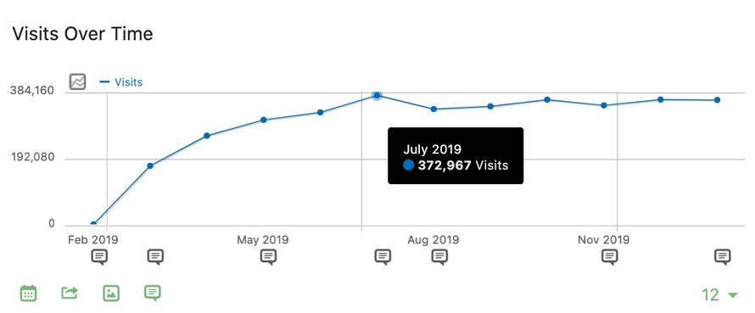
a. Changing Plotted Metrics
To modify the metrics displayed in an Evolution Graph, click on the line chart icon at the top left of the graph. This will open a list of all available metrics for that visualization. Simply check the box next to any metric you'd like to include, and the page will refresh to show the updated data.
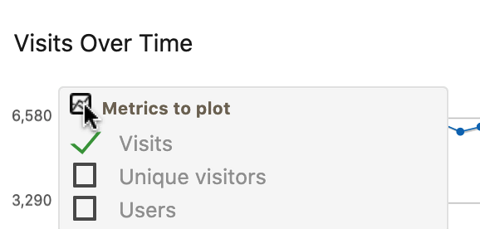
b. Evolution Graph Menu
While your mouse is over the Evolution Graph card, you will notice a green icon menu appear in the bottom left.
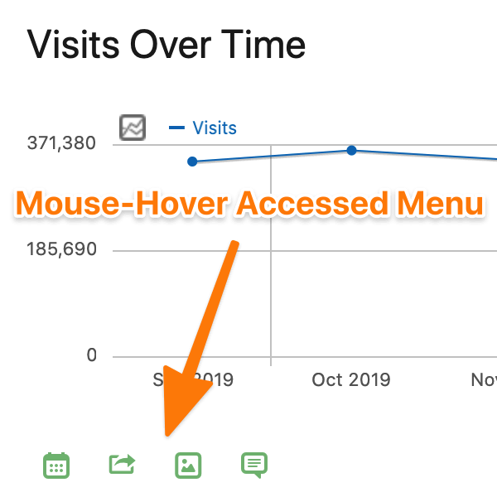
The features within this menu are as follows:
- Calendar Icon – Allows you to adjust the graph to display data in days, weeks, months, or years.
- Export Icon – Lets you export the data into various formats for use in other software.
- Image Icon – Downloads the data as an image, useful for compiling reports for clients or management. Right-click and save the file to your device.
- Annotation Icon – This feature helps provide context for changes in your data. It displays a list of annotations within the selected date range, and you can add your own annotations for further clarification.
2. Tables
Tables are another useful data visualization format for reviewing your data. Typically, tables display a primary dimension, such as a page or traffic source, on the left side. This is followed by various associated metrics in columns on the right side. You can explore additional data and features by hovering your mouse over rows and metrics.
a. Flattening Reports
By default, many table reports in Matomo are loaded in a hierarchical format. This means similar data types are grouped under high-level categories, which you can expand to view more detailed data. For instance, in a report, you might focus on the number of visitors from different channel types like search engines. However, if you're analyzing landing pages to optimize your site, you'd likely prefer to see reports for individual pages instead of aggregated groupings.
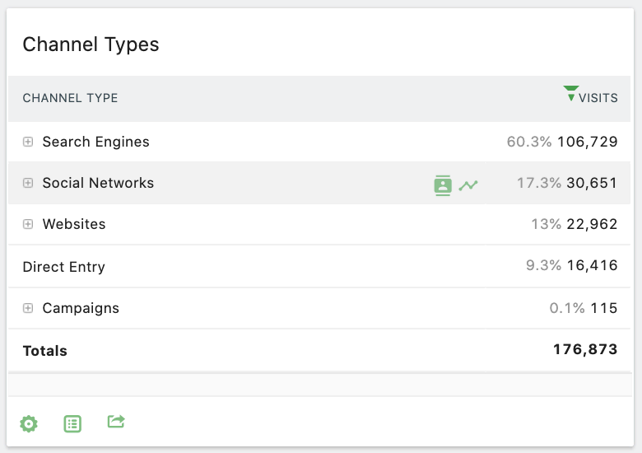
To see the more detailed view, you will need to either expand your selection or flatten the table as a whole.
- Expanding your selection – Click on the plus icon to the left of the row to reveal individual items that has been rolled up into a top-level hierarchy. You can also re-flatten a row with the minus icon.
- Flattening your table – Do this if you want to see the complete data set broken down into individual entries. Move your mouse to the table section and click on the green cog icon that appears in the bottom left. This brings up a table configuration menu where you can make it flat along with a few other options depending on the data being shown.
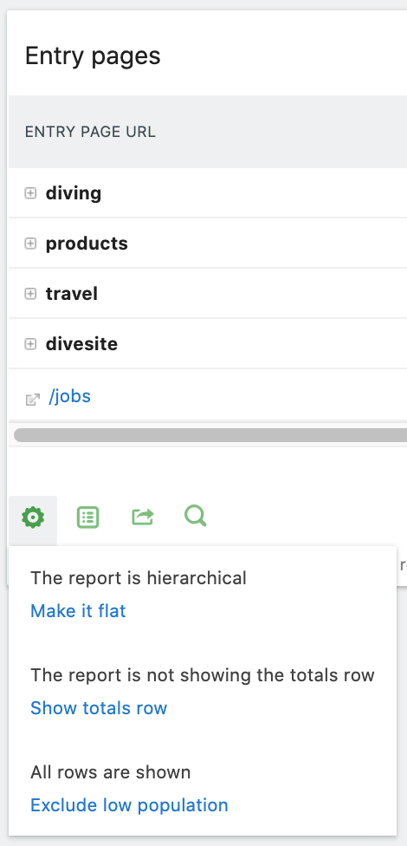
b. Show Table Totals
You may be interested to learn the metric totals for each column in the table. You can do this by moving your mouse into the table area and clicking on the green cog icon to bring up that same menu and then click on Show totals row.
c. Revealing Extended Table Data Options
Tables within Matomo will load all available data for the most common metrics. However, many reports provide options to customise the data shown in the table. To explore the available options for a table report, click the green cog icon in the bottom left of the table. The specific options will vary between reports but can include options such as, showing totals, or removing infrequent data values.
d. Searching within reports
You will also notice a search icon below most tables. Clicking this will reveal a search bar. You can then type in the data you are looking for and hit the Enter or click on the Search icon again to search. For example, in the “Keywords” report, you can search for nature and it would return all keywords matching nature
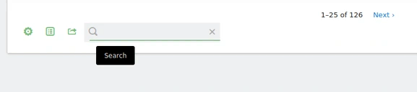
3. Sparkline Summary Cards
These summaries are typically displayed on overview pages, providing a concise snapshot of key data related to a specific topic. For instance, on the Goals page, you'll find an overview that highlights the total number of conversions, the conversion rate, and the total revenue generated from goal completions.
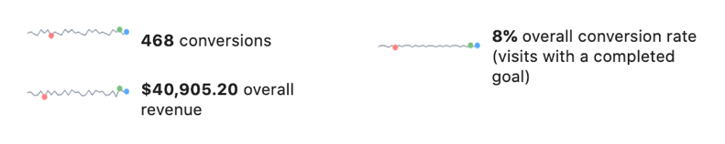
Sparkline summary cards present a concise visualization of your data, featuring a line chart on the left and a text summary on the right. The line chart spans the date range selected in the Date Selector. Key points on the chart are marked with coloured bubbles red for the lowest value, green for the highest, and blue for the most recent data point.
While these summary cards don't have configurable settings, they do offer two notable features. First, hovering over the text summary provides a more detailed explanation of the displayed data. Second, clicking on any item within the card updates the Evolution Graph to showcase the corresponding data.
4. Maps
The Map view is a location-based data visualization tool, most relevant when analyzing geographic data. By default, it displays a world map. You can explore more detailed insights by clicking on a country to view a regional breakdown. Further, clicking on specific regions reveals an Evolution Graph for that area.
It's important to note that location data is derived from visitors' IP addresses. As a result, the accuracy of this data may vary depending on your Matomo privacy settings and configuration.
The primary way to access location analytics data within Matomo can be found on the Locations page which is situated in the Visitors section of the main navigation menu. This page displays a map at the top left of the report which provides aggregate data on visits for a specific website, time and segment as defined by the data selectors at the top of the page.
